Powerpoint Guide:

- Every slide should have more visuals than words.
- You should not be reading anything off of your slides
- You cannot put fully solved problems on your slide. You may write questions or variables, but you must be able to solve it on the spot.
- You may not use any notecards during your presentation.
- No more than three slides

Physics POL Rubric – Semester 2 – 2018
ESK & Habit of Mind | Grading Expectations |  |  |  | POL Grade
 | 4 Check = 4 | 3 Checks = 3 | 2 Checks = 2 | 1 Checks = 1
Habit of Mind:  Presentation Accountability | - Professional Dress, including shoes for the entirety of POLs  - Uses resources in the room to enhance presentation (whiteboard, projector, visuals)  - Utilizes time effectively during presentation (not too short/too long)  - Productive, punctual and respectful member of POL audience and panel
Habit of Mind: Presentation Quality | - Speaks clearly, towards the audience, with accurate pronunciation and presentation volume.  - Makes eye contact and maintains a calm, present demeanor.  - Body language is confident and professional.  - Has a neatly organized, well-planned explanation that is easy to follow.
ESK 4.1/4.2  ESK 5  ESK 6.1/6.2 | 4 3 2 1  - Presents complete thought process of evidence to explain understanding of ESK. - Can analyze mistakes and corrections, can answer prompted questions thoughtfully and thoroughly. - Can apply multiple representations to show understanding of ESK without prompting. - Presentation demonstrates a full and complete understanding of ESK - Presents most of thought process of evidence to explain understanding of ESK. - Can analyze mistakes and corrections, can answer most prompted questions. - Can apply multiple representations to show understanding of ESK with some prompting. - Presentation demonstrates a partial understanding of ESK - Presents some of the thought process of evidence to explain ESK. - Can analyze some mistakes and corrections, and can only answer some of prompted questions. - Can apply multiple representations to show understanding of ESK with a lot of prompting. - Presentation demonstrates a partial understanding of ESK - Does not show thought process to explain ESK. - Cannot analyze mistakes and corrections, cannot answer most of the prompted questions. - Cannot apply multiple representations to show understanding of ESK. - Presentation demonstrates an incomplete or no understanding of ESK
Pass
No Pass

Honors Physics POL
Extra Terrestrial Theme Park

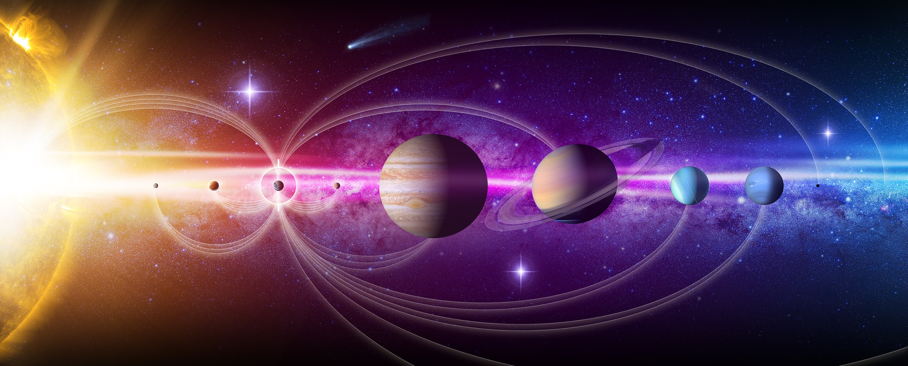

Goal: Take your theme park to another body within our solar system.
Design a ride that will let your park goers experience what gravity feels like on earth.

My park is going to: _________________________________

- I can explain why the gravity is different on my celestial object, and how that would affect projectile objects.
- I can calculate the speed, and distance at which a projectile object would move on my planet/moon.
- I can compare the annual orbit of the planet (around the sun)/moon (around the planet) to the orbit of Earth.
- I can use the concepts of circular motion to explain why my orbit would be larger or smaller that Earth’s.
- I can identify 3 big issues humans would have, when trying to live on this object. I can use evidence from The Martian to support my reasoning for my solutions to these problems.

