HONORS Physics POL
- A rock is thrown horizontally at a speed of 5.1 m/s from the top of a cliff 85 m high.
a) How long does it take the stone to reach the bottom of the cliff?
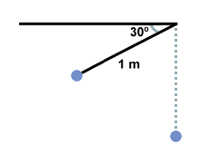
b) The stone strikes the ground how far from the base of the cliff?
2. A 2kg pendulum with string of length 1 m is raised to an angle of 30 º below the horizontal, as shown below, and then released. What is the velocity of the pendulum when it reaches the bottom of its swing?

3. A boulder rolls with speed of 3.5 m/s off a cliff. It hits the ground 2.25 m from the base of the ledge.
a) How high is the ledge?
b) How long did it take the boulder to fall to the bottom of the cliff?
4. A football, kicked at an angle of 50° to the horizontal, travels a horizontal distance of 20 m before hitting the ground. Find (a) the initial speed of the football, (b) the time it is in the air, and (c) the maximum height it reaches.
5. From the edge of a 60.0 m cliff, Wile E. Coyote leaps upwards with a velocity of 23 m/s at an angle of 50 degrees above the horizontal. At what point above the ground does he strike the wall of a vertical cliff located 20.0 m away?
6. Find the length of a pendulum that has a period of 1.5s. How would the length change if this pendulum was taken to Jupiter which has 10 times the amount of gravity as Earth?
7. The punter on a football team tries to kick a football so that it stays in the air for a long “hang-time” while traveling as far down the field as possible. If the ball is kicked with an initial velocity of 25.0 m/s at an angle of 60.0° above the ground, what is (a) the “hang-time”, and (b) the distance between the punter and the point where the ball lands?
8. A home run is hit in such a way that the baseball just clears a wall 21 m high, located 130 m from the home plate. The ball is hit at an angle of 35° to the horizontal, and air resistance is negligible. Find (a) the initial speed of the ball, (b) the time it takes the ball to reach the wall, and (c) the velocity components and the speed of the ball when it reaches the wall. (Assume the ball is hit at a height of 1.0 m above the ground.)
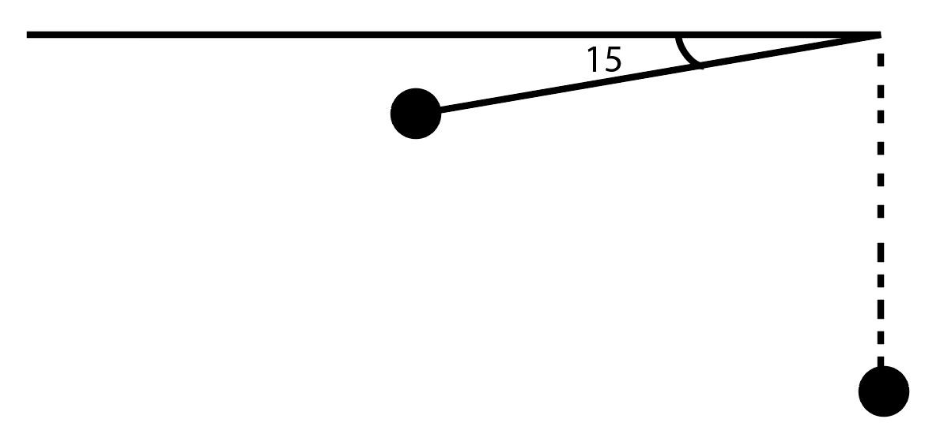
9. How much potential energy does the 1.5 kg pendulum have when it is dropped if the length of the string is 1 meter long? How long will it take for the pendulum to reach the other side?

