**ESK 6 Conservation of Energy POL**

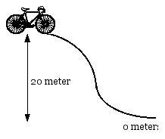

1. You are at the top of a hill at a speed of 5.0 m/s. Your and your bike’s masses together are 90. kg.

* 1. What's your total energy?
  2. How fast are you going at the bottom of the hill?

2. A boy is sitting on a sled at the top of a 23 m high hill. If the total mass of the boy and the sled is 37 kg, how fast will he be going when he reaches the bottom of the hill?

1. A bag of cement with mass of 16 kg falls into a river from a 12 m high bridge. What is its speed just before it hits the water?

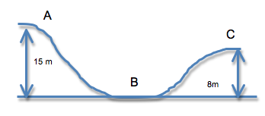

1. The roller coaster’s mass is 100 kg and it starts from rest at point A.
2. Find the KE at point B
3. Find the speed at point C

5. If a car, when moving at 30 km/h, has 10 J of kinetic energy, how much kinetic energy would it have if it:

a. Doubled its speed to 60 km/h?

b. Tripled its speed to 90 km/h?

6. A roller coaster starts at rest and then rolls down a big hill and is moving at 20 m/s at the bottom of the hill. If the roller coaster has a mass of 190kg then how tall was the hill?

7. 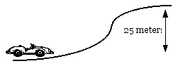You approach a hill in your 950 kg car at a speed of 25 m/s. If you take your foot off the petal, will you have enough energy to make it up the hill?

a. If not, how much more energy do you need? If you have enough, how much KE do you have left at the top of the hill?

8. Assuming the height of the hill is 40.0 m, and the roller coaster car starts from rest at the top, calculate:

a. the speed of the roller coaster car at the bottom of the hill.

b. at what height it will have half this speed.

9. A bowling ball is dropped from the top of a building. If it hits the ground with a speed of 37.0 m/s, how tall was the building?

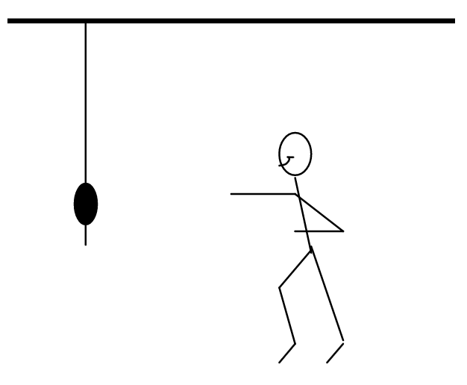10. An 80.0 kg student running at 3.5 m/s grabs a rope that is hanging vertically. How high will the student swing?