ESK 5.1 Circuits POL

1. Draw a circuit with 1 bulb, battery and 4 switches. Make your circuit so that if 2 switches are open and 2 switches are closed, the circuit works.

2. Draw a circuit with 3 bulbs in parallel with one switch that controls only ONE bulb. (meaning the other two stay on when you open the switch)
b. Draw a circuit with 2 bulbs in series and 2 bulbs in parallel. (no switches)

3. Draw a circuit with 2 bulbs in series and 2 bulbs in parallel. (no switches)
Are light bulbs brighter in a series or parallel circuit? WHY?

4. Are Christmas lights hooked up in series or parallel? Draw and explain how you would test this out to prove it.

5. Label each circuit as Parallel, Series or Combination. Explain how you know this.
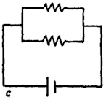
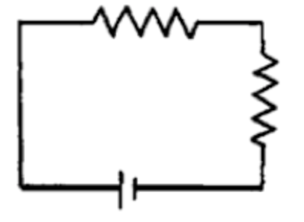
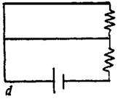
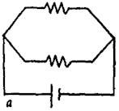
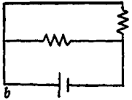

6. Which of these circuits work, and which ones won’t work. Explain why or why not. 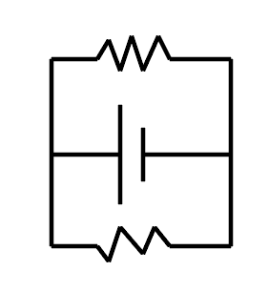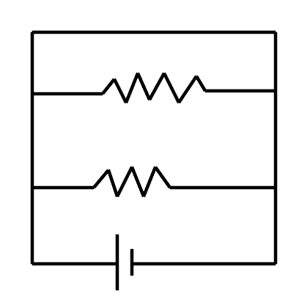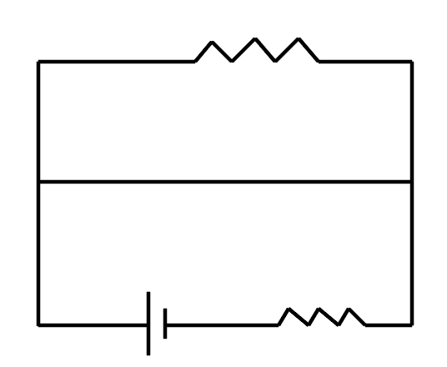

7. Make a complex circuit with 4 bulbs, 2 batteries, and 2 switches. Explain the difference between the series and parallel sections.

8. Draw 3 different circuits each with 3 bulbs, a battery and a switch. Make 2 of them work, and one of them have a short circuit. Explain where the short circuit happens, and why.

9. Draw a circuit with 3 bulbs in parallel with one switch that controls all 3 at the same time.
If you increase the voltage of a circuit, what happens to the current?
If you increase the voltage of a circuit, what happens to the current?

10. Make a complex circuit with 5 bulbs, and a battery. Explain which light bulbs are brighter and dimmer, explain why.

