ESK 4.1/4.2- Energy
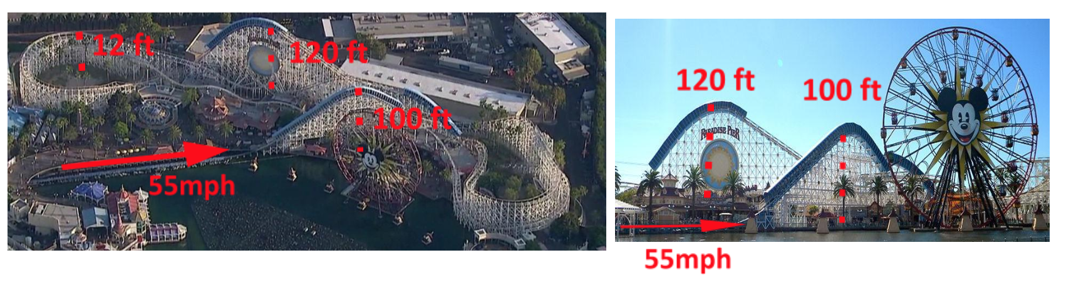

Requirements | POL Presentation
- Design a roller coaster (Digital or Hand drawn)  - Give measurements for the height of the roller coaster at 5 different places  - One should be the highest point in the roller coaster, and one should be the lowest point  - Choose an initial speed for the roller coaster and prove that energy will be conserved throughout the entire ride | - I can explain the design of my roller coaster and how it fits with the overall theme of the park.  - I have identified 5 different heights in my roller coaster that are reasonable.  - I have an initial speed for my roller coaster that is reasonable.  - I can prove that the roller coaster has enough energy to reach the top of a roller coaster at a reasonable speed using systems of equations.  - I can prove that the roller coaster has enough energy to go through the lowest part of the roller coaster at a reasonable speed using systems of equations.  - I can solve for the speed of the roller coaster at any given height.

Powerpoint Guide:

- Every slide should have more visuals than words.
- You should not be reading anything off of your slides
- You cannot put fully solved problems on your slide. You may write questions or variables, but you must be able to solve it on the spot.
- You may not use any notecards during your presentation.
- No more than three slides

Physics POL Rubric – Semester 2 – 2018
ESK & Habit of Mind | Grading Expectations |  |  |  | POL Grade
 | 4 Check = 4 | 3 Checks = 3 | 2 Checks = 2 | 1 Checks = 1
Habit of Mind:  Presentation Accountability | - Professional Dress, including shoes for the entirety of POLs  - Uses resources in the room to enhance presentation (whiteboard, projector, visuals)  - Utilizes time effectively during presentation (not too short/too long)  - Productive, punctual and respectful member of POL audience and panel
Habit of Mind: Presentation Quality | - Speaks clearly, towards the audience, with accurate pronunciation and presentation volume.  - Makes eye contact and maintains a calm, present demeanor.  - Body language is confident and professional.  - Has a neatly organized, well-planned explanation that is easy to follow.
ESK 4.1/4.2  ESK 5  ESK 6.1/6.2 | 4 3 2 1  - Presents complete thought process of evidence to explain understanding of ESK. - Can analyze mistakes and corrections, can answer prompted questions thoughtfully and thoroughly. - Can apply multiple representations to show understanding of ESK without prompting. - Presentation demonstrates a full and complete understanding of ESK - Presents most of thought process of evidence to explain understanding of ESK. - Can analyze mistakes and corrections, can answer most prompted questions. - Can apply multiple representations to show understanding of ESK with some prompting. - Presentation demonstrates a partial understanding of ESK - Presents some of the thought process of evidence to explain ESK. - Can analyze some mistakes and corrections, and can only answer some of prompted questions. - Can apply multiple representations to show understanding of ESK with a lot of prompting. - Presentation demonstrates a partial understanding of ESK - Does not show thought process to explain ESK. - Cannot analyze mistakes and corrections, cannot answer most of the prompted questions. - Cannot apply multiple representations to show understanding of ESK. - Presentation demonstrates an incomplete or no understanding of ESK
Pass
No Pass

