ESK 3 Gears
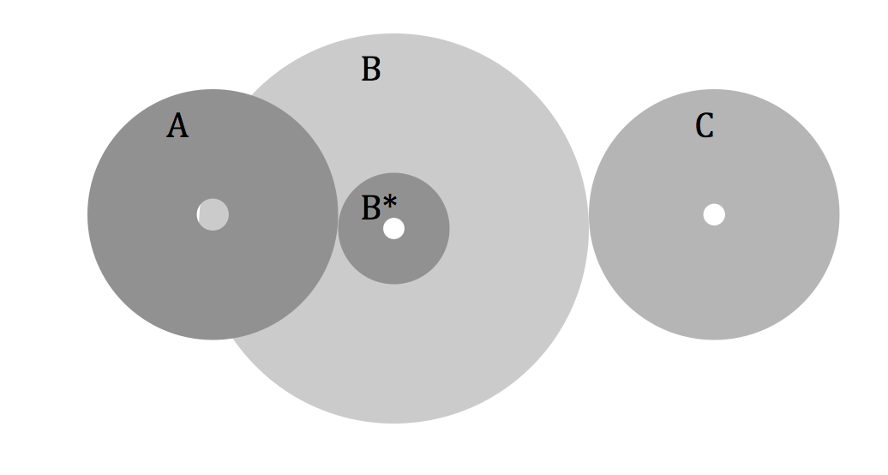
28 teeth

6 teeth

30 teeth

50 teeth

- Which gear will spin the fastest? Calculate the ratios between all gears.

- Chris want to design a robot with a gear ratio of 2, using a 16 tooth Driven gear. He has 40, 32, 24, 16, 14 and 8 tooth gears available. What gear should he choose as his driving gear? Explain/Solve.

- I want to design a robot with as low a gear ratio as possible in order to reach the greatest speed. I have 40, 36, 24, 14, 12 and 8 tooth gears available. Which two gears should I choose? What would be the lowest ratio possible with these combinations?

- Jessica needs to create a car with a gear ratio o f 2/5, using a 60 tooth driving gear. Give at least 2 examples of other gears that she could pair with her driving gear.

- Draw and label the parts of a planetary gear. If the ring has 80 teeth give two options for the other sizes.
- Sun gear is smaller than the others
- Sun gear is larger than the others

- Which gear will spin the slowest? Calculate the ratios between all gears.
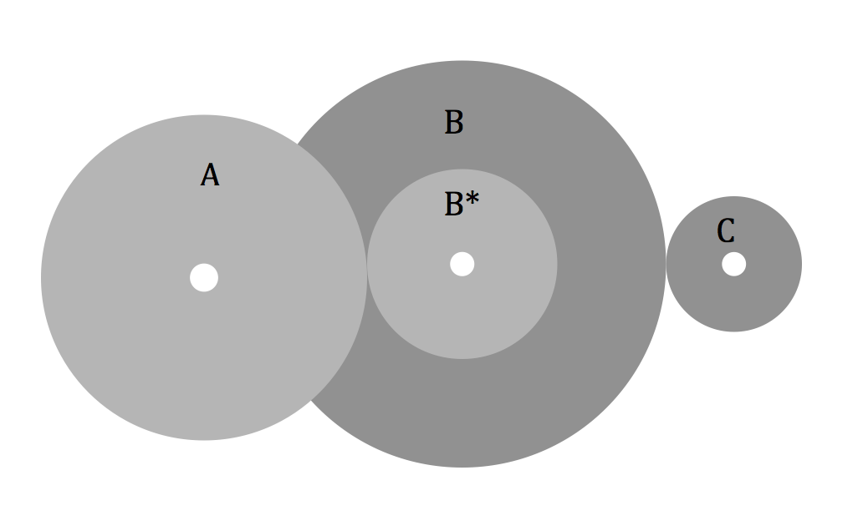
36 teeth
20 teeth
48 teeth
12 teeth
- Maria wants to design a clock using gears. She needs to make a gear that rotates the minute hand, and a gear that rotates the hour hand. What would be the gear ratio between both hands? Give an example of two gears that would work for each hand.

- An astronomer wants to build a 'clock drive' that will allow his telescope to keep up with the rotation of Earth so that stars will not move as he is looking at the sky with his telescope. To do this, the gear has to rotate exactly once each day, which lasts about 1437 minutes. He has a motor which rotates once every minute.
The astronomer has the following gears with the indicated number of teeth: 1395, 309, 20 and 15. What combination will give him a ratio close to 1:1437 minutes? (Hint: you will have to use all 4 gears in compound. You need to figure out the correct order)

- Brandon has a 4-speed bike and wants to pedal only 5 times to get to the top of a hill. He knows his wheel needs to spin 6 times. Which speed should he use?
 | Pedal | Back Wheel
Speed 1 | 10 teeth | 10 teeth
Speed 2 | 12 teeth | 10 teeth
Speed 3 | 10 teeth | 24 teeth
Speed 4 | 12 teeth | 24 teeth

- Design a set of compound gears using 4 gears so that the ratio from first to last gear is 4:1.

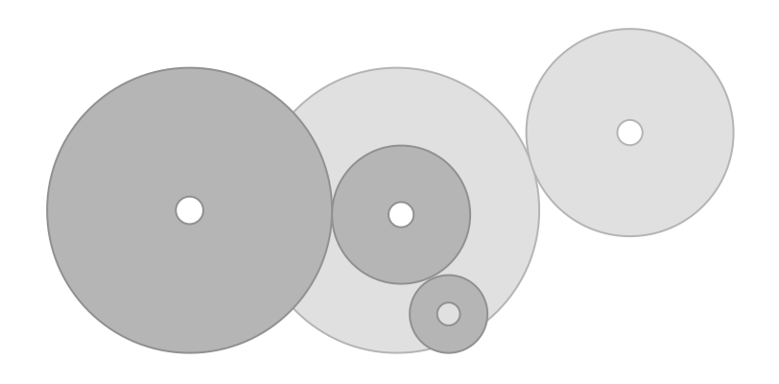
A
- Which gear spins the fastest? Find the ratio from A to D, and from C to D.
32 teeth
8 teeth
18 teeth
40 teeth
40 teeth
C
D
B*
B
- A bicycle has 2 gears in on the pedals, one of which has 30 teeth and the other 24. The bicycle also has 5 gears on the back wheel, with 8, 12, 16, 20, and 24 teeth. List all the pairs of possible combinations of gears. How many unique gear ratios does this bicycle have?

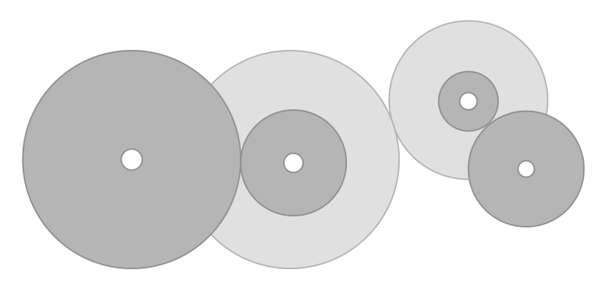
- Find the gear ratio from A to D. Which should be moving the fastest?
24 teeth
10 teeth
34 teeth
20 teeth
48 teeth
50 teeth
B*
C*
B
C
D
A
- Design a set of compound gears using 6 gears so that the ratio is 2:1.

