ESK 2
Motion Graphs
On a position-time grap, sketch a plot representing the motion of an object which is doing the following motions. Label each line with the corresponding letter (e.g., "1", "2", "3", etc.)
- at rest.
- moving in the positive direction with constant speed
- moving in the positive direction and speeding up
- moving in the positive direction and slowing down
- moving in the positive direction at a constant speed (slow) and then later fast at constant speed

Consider the position vs. time plots below. Sketch the shape of the corresponding velocity vs. time graphs. The circle on the first graph represents the point (2 seconds, 3 meters) Find the speed of that first line segment.
time
position
time
position

time
velocity
time
velocity

Draw a position vs. time graph of a person walking at a constant speed of 1 m/s for 3 seconds. The stopped for 3 seconds. Then walking at a constant speed of 2 m/s for 5 more seconds. How far did they walk?

You drop a ball from the edge of a cliff. It free falls and lands 4 seconds later.
  - Make a table showing the ball’s speed each second for 4 seconds.
Make a position graph for the ball for 6 seconds. Explain the shape and what is happening during each second.

Draw the position vs. time graph for a person walking at a constant speed of 1 m/sec for 10 seconds. On the same axes, draw the graph for a person running at a constant speed of 4 m/sec. Draw a velocity vs. time graph for each person and explain the differences and similarities.
Consider the velocity-time plots below. Sketch the shape of the corresponding position-time graphs.
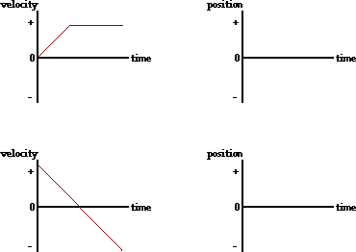

For the plots below, determine the velocity of the object:
- from 0.0 - 5.0 seconds  - from 5.0-10 seconds | c. from 5.0 - 10.0 seconds | d. at 13.0 seconds

3 people are all running a race.

position
a
c
b

Who is has run the farthest?
Who has run for the longest amount of time?
What can you tell me about their speeds?
If I gave you exact numbers on the graph,
how would you find the speed of each person?
time
What is the acceleration of person B?

A car is driving down an empty road. It stops at a stop sign and then continues on. Which distance vs. time graph best represents this situation? Is the car traveling at a constant speed the whole time? Explain how you know.
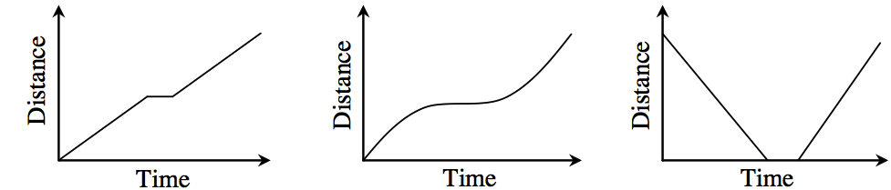

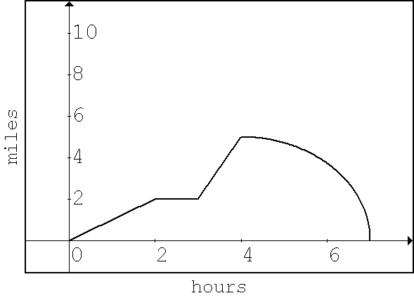
Thomas and Samantha went for a hike. They recorded data about their journey in the graph at right. Describe what they are doing during the hike. Be as detailed as possible. (When are they walking the fastest and slowest) Explain how you know this. How far did they hike? What was their average speed for the entire trip.

Sam rolls down his driveway on a skateboard while Beth keeps track of his position every second for 15 seconds. When they make a graph of the data, the position vs. time graph is a curve that gets steeper as time increases. What does this tell you about Sam’s speed? What would a speed vs. time graph look like for this situation?

A car is driving down an empty road. It stops at a stop sign and then continues on. Which graph best represents this situation? ? Is the car traveling at a constant speed the whole time? Explain how you know.
