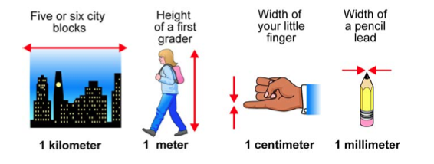
Dimensional Analysis Guide
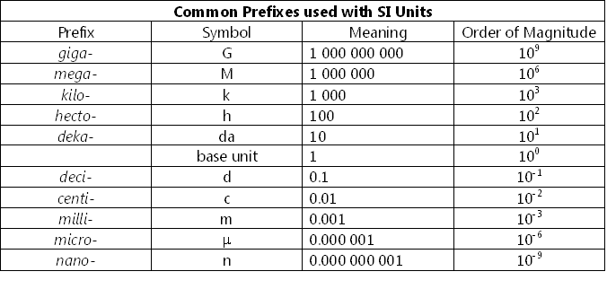
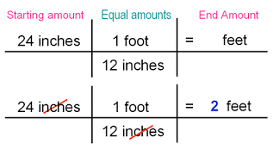

1 mile = 1.6 kilometers | 1 week = 7 days
1 mile = 1609 meters | 1 day = 24 hours
1 km = 1000 meters | 1 inch = 2.54 centimeters
1 hour = 60 minutes | 1 pound = 16 ounces
1 minute = 60 seconds | 1 kg = 2.205 pounds
1 meter = 100 centimeters | 1 cup = 16 ounces
1 kg = 1000 grams | 1 quart = 4 cups
1 year = 12 months | 1 gallon = 16 cups
1 month = 30 days | 1 pint = 2 cups

