Corn Hole Board Instructions

Materials
1/2″ thick sheet of plywood 2’x4’
2×4’s
4 1/2″ long 3/8″ diameter carriage bolts
3/8″ flat washers
3/8″ wing nuts
2 1/2″ wood screws
4 Bean bags

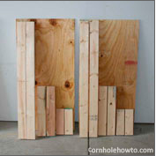
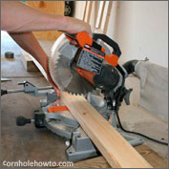
The first step to building your corn hole table is to cut your wood. Always refer back to your Sketchup drawing to ensure your measurements are correct.

You’ll need boards with the following lengths:
48 inches (2) (frame sides)
21 inches (2) (frame ends)
11.5 inches (2) (legs)

Cut the 2x4s with a mitre saw.
Because of this we suggest you measure, cut, measure, cut, and so on rather than make all your measurements at once. If you purchased a larger piece of plywood, measure and cut your plywood down to size. One side should already be 4 feet long so now just cut it to be 2 feet wide. Use the table saw to cut down your large piece of plywood.
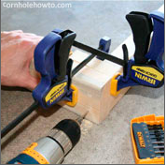
Use the wood screws to build a rectangular box with [2] 21” pieces and [2] 48” pieces. The 21-inch pieces must be inside of the 48-inch pieces. These will form a 2’ x 4’ box. Use a couple of clamps to hold the frame together nice and flush. Countersink your screws if you don’t want them to show after you pain
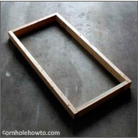
However you do it, you’ll want all of your corners and edges to be flush with the other board. Keep in mind that even an apparently straight 2×4 can have a slight bend to it. You may need to torque your boards just a bit to get the last corner together properly. Don’t worry, a little distortion will work itself out.
Tip: Drill your hole first with a drill bit slightly smaller in diameter than your screws. This makes it a little easier putting the screws in and ensures your wood doesn’t split as the screw goes in place. Also make sure to put the correct ends together. If you don’t, your frame will have the wrong dimensions!
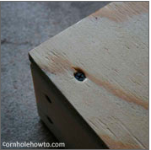
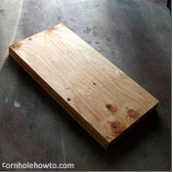
Now put your plywood surface on the frame and screw it down.

(Pre-drill the holes again, or the wood will split)

Drill a hole every 6 inches or so along the frame of the board.

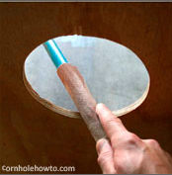
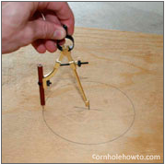
Mark the center of the hole – 9″ from the top end of the board and 12″ from either side.
Use a compass or something of the sort to draw a circle six inches in diameter.
(You can use a pencil tied to a piece of string if you need to.)

Use he 6 inch drill bit to drill out the hole, then sand along the edge.
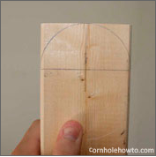
Next come the legs of your corn hole board. It must raise the end of the corn hole table 12 inches off the ground. It must also be sturdy enough to withstand an onslaught of corn hole bags.
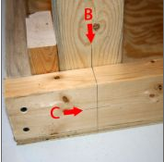
The picture to your left illustrates what we’re shooting for in the end. Make a round cut on the end of each leg using the jig saw. To make the cut, measure 1-3/4" down the length of the 2x4 and draw a line across it. Place a compass point centered on that line then draw the arc.
Turn the box upside down; lay a leg parallel, flush up against one of the top corners with the radius side in the corner. Clamp into place.
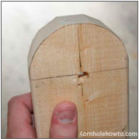
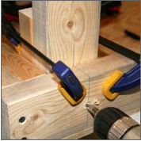
Now, we’ll mark the hole for your bolt. Transfer your leg’s midpoint line (line B) onto the frame. Measure the midpoint of the frame’s 2×4 (line C) which again should be around 1 ¾”. Do not include the plywood in this measurement, just the 2×4 of the frame! Where these two lines intersect is where we want the bolt to go, right through the center of the frame and leg. Drill a 3/8” hole through the side of your table and leg. You’ll notice I used clamps to hold things in place and I’ve got an extra board clamped in behind my leg (picture on next page). This extra board will give me a nice clean hole all the way through each piece of wood and reduces splintering.

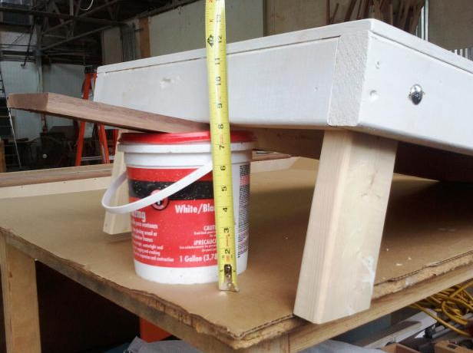

Now that your legs are properly trimmed, assemble your bolts, washers, and wing nuts. Sliding the carriage bolt through the hole in the frame (you might need to twist it through the hole) you’ll find the square shoulder of the bolt keeps things from becoming nice and flush. Take a hammer and gently tap the carriage bolt into the wood frame until it and the washer are flush with the wood surface.
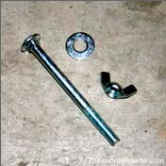
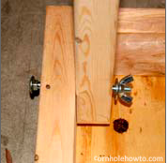

Bean Bag Instructions

Materials
Fabric
Corn Feed
Sewing Machine
Fabric Dye
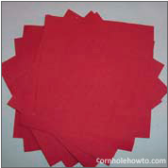
For the bean bags, we will double bag them to prevent them from breaking. Since you are making 4 bags, you need a total of 16 individual sheets that measure 7 inches by 7 inches.

You will pair up two sheets together and sew ½ inch from the edge in a straight line. Repeat this on all sides until you get to the last side. For the inside bags, sew half of it shut, for the outside bags leave this side completely open.

Repeat this for all of the bags. Since you have inside and outside bags, you will have a total of 8 bags.

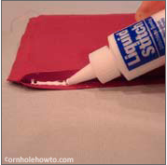
For each bag, use hot glue to help keep the bags sealed.

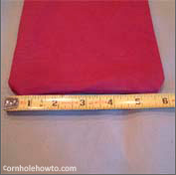
Measure out exactly 15 ounces of corn feed to use to fill the inside bag. Glue the last side shut and then hang sew, or use the machine to reinforce the last side.

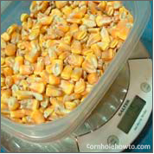
For the outer bags, they need to be dyed a different color from the other team, so coordinate what colors you will be using. Dye the bags and then rinse them before stuffing them with the inner bag.

Lastly, fold the open edge inside the bag and then hand stitch or put through the sewing machine to finish off the last end of the bag.

In the end, the outer bag should be a 6 inch square.

