**Scientist:**_______________________________________

**Gear Ratio Worksheet**

Gear ratios are written **Driven** gear to **Driving** gear. Always remember to reduce to the lowest common denominator.

**In all of the following examples Gear A is the driving gear and Gear B is the driven gear.**

**# of teeth** **RATIO HOW MANY TIMES**

A= 10; B=20 ___________ If A turns one time, B will turn _____________________________.

A= 40; B=10 ___________ If A turns one time, B will turn _____________________________.

A= 36; B=60 ___________ If B turns one time, A will turn _____________________________.

A= 12; B=28 ___________ If A turns one time, B will turn _____________________________.

A= 40; B=20 ___________ If A turns one time, B will turn _____________________________.

A= 6; B=30 ___________ If B turns one time, A will turn _____________________________.

A= 12; B=60 ___________ If A turns one time, B will turn _____________________________.

A= 84; B=36 ___________ If A turns one time, B will turn _____________________________.

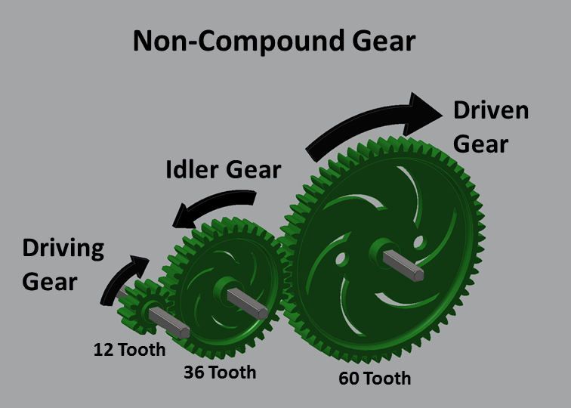

**Multiple Gears in a Train:**

In gear-trains in a line the ratio will change from set to set, but ends as a ratio from the first to the last.

Example: A has 10 teeth; B has 50 teeth; C has 40 teeth.

The ratio for A:B is 5:1; the ratio for B:C is 4:5. Multiply 5:1 x 4:5 which gives you 20:5 and you can simplify to 4:1. *Simpler to ignore all idler gears. A:C = 4:1*

**In all of the following examples Gear A is the driving gear, Gear B is the idler, Gear C is the driven gear.**

**# of teeth**  **RATIO HOW MANY TIMES**

A= 10; B=20; C=10 _________________ If A turns one time, C will turn _________________.

A= 10; B=40; C=5 _________________ If A turns one time, C will turn _________________.

A= 12; B=36; C=60 _________________ If C turns one time, A will turn _________________.

A= 84; B=12; C=36 _________________ If B turns one time, C will turn _________________.

A= 36; B=60; C=84 _________________ If A turns one time, C will turn _________________.

If you can basically ignore the idler gear, what do you think is the purpose of an idler gear?