Scientist \_\_\_\_\_\_\_\_\_\_\_\_\_\_\_\_\_\_\_\_\_\_\_\_\_\_\_\_ Period: \_\_\_ **Bill Nye and Gravity**

**Answer these questions as you watch the video.**

1. What makes the earth go around the sun? \_\_\_\_\_\_\_\_\_\_\_\_\_\_\_\_\_\_\_\_\_\_\_

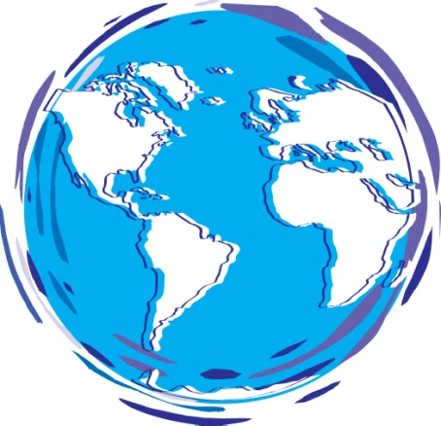

2. **Does gravity push or pull**? \_\_\_\_\_\_\_

3. Does gravity affect the **air we breathe**?\_\_\_\_\_\_

4. \_\_\_\_\_ **Where does gravity pull towards?**

A. Up

B. Down

C. Sideways

D. All directions

5. **When the apple and the bowling ball are dropped together:** \_\_\_\_\_\_\_\_\_

a.) they both hit the ground at the same time

b.) the apple hit the ground first

c.) the bowling ball hit the ground first

6. Who dropped **a feather and a hammer** together to see if gravity pulled on them the same

amount? \_\_\_\_\_\_\_\_\_\_\_\_\_\_\_\_\_\_\_\_

7. **What happened** to the feather and hammer when dropped? \_\_\_\_\_\_\_\_\_\_\_\_\_\_\_\_\_\_\_\_\_

\_\_\_\_\_\_\_\_\_\_\_\_\_\_\_\_\_\_\_\_\_\_\_\_\_\_\_\_\_\_\_\_\_\_\_\_\_\_\_\_\_\_\_\_\_\_\_\_\_\_\_\_\_\_\_\_\_\_\_\_\_\_\_\_\_\_\_\_\_\_\_\_\_

8. We use a \_\_\_\_\_\_\_\_\_\_\_\_to measure our weight.

9. \_\_\_\_\_ **As gravity pulls down on us the springs in the scale get** \_\_\_\_\_\_\_\_\_\_\_\_\_\_\_.

A. Pulled Apart

B. Squeezed

10. **True or False** The more the scale’s springs get squeezed, the more you weigh.

11. **Weight** comes from **our mass**, **Earth’s mass** and \_\_\_\_\_\_\_\_\_\_\_\_\_\_\_\_.

12. \_\_\_\_\_ All the **planets** in **orbit around the** \_\_\_\_\_\_\_\_\_ are held in place by gravity.

A. Earth

B. Moon

C. Sun

13. \_\_\_\_\_ **Why don’t the planets get pulled into the sun?**

A. They are in motion

B. They have anti – gravity in them

C. They do – just slowly

MCNA01827_0000[1]14. Our Earth is going around the Sun at about \_\_\_\_\_\_\_\_\_\_\_\_\_ **kilometers per hour**.

15. Jupiter is  **larger or smaller**  than the Earth

16. Jupiter has \_\_\_\_**more or less** gravity than the Earth

17. The moon is smaller, so it has \_\_\_\_\_\_\_\_\_\_\_\_\_\_\_\_\_\_ gravity.

18. The **pull of gravity makes the earth** and all planets into this **shape**  \_\_\_\_\_\_\_\_\_\_\_\_\_\_\_.

19. With gravity things fall \_\_\_\_\_\_\_\_\_\_\_\_\_\_\_\_\_\_\_\_\_\_.

20**. Quote from Skateboarding section:**

One thing that always remains constant is gravity.

Gravity will always be the \_\_\_\_\_\_\_\_\_\_\_ no matter where you go or how you do it.

(This is true anywhere on Earth.)

21. Gravity pulls us down toward the \_\_\_\_\_\_\_\_\_\_\_\_\_ of the earth.

MCj03039770000[1]

22. \_\_\_\_\_ **Name the scientist known for dropping two bowling balls of different weights off the Leaning Tower of Pisa.**

A. Sir Isaac Newton

B. Galileo

**After the movie:**

23. Write a one sentence definition of what gravity is.

\_\_\_\_\_\_\_\_\_\_\_\_\_\_\_\_\_\_\_\_\_\_\_\_\_\_\_\_\_\_\_\_\_\_\_\_\_\_\_\_\_\_\_\_\_\_\_\_\_\_\_\_\_\_\_\_\_\_\_\_\_\_\_\_\_\_\_\_\_\_\_\_

\_\_\_\_\_\_\_\_\_\_\_\_\_\_\_\_\_\_\_\_\_\_\_\_\_\_\_\_\_\_\_\_\_\_\_\_\_\_\_\_\_\_\_\_\_\_\_\_\_\_\_\_\_\_\_\_\_\_\_\_\_\_\_\_\_\_\_\_\_\_\_