Scientist_____________________________________________________ Per_______ Date___________________
Free Fall Graphing
Time (seconds) | Position (meters) | Speed  (meters/second)
0 | 0 | 0
1 | 5 | 9.8
2 | 20 | 19.6
3 | 45 | 29.4
4 | 80 | 39.2
5 | 125 | 49
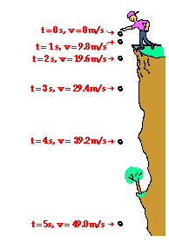
The picture on the right shows a person dropping a ball off of a cliff. The data table below describes what happens to the position and the speed of the ball for the first 5 seconds. On the back, graph the position vs. time and speed vs. time for the data below. Analyze the graphs and answer the questions below.

- Describe, in your own words, what the object is doing as it is falling. (you cannot use the word acceleration)

- How much is the speed changing each second? Is it a constant value or a changing value?

- What does the shape of the position graph tell you about the object.

- What does the shape of the speed of the graph tell you about the speed of the object.

- Is the object accelerating? How do you know?

- Calculate the acceleration of the object. (Find the slope of the speed graph)

