Scientist: __________________________________ Per: _________ Date: __________
Weekend Graphing HW
Answer the series of questions using the following position-time graph.
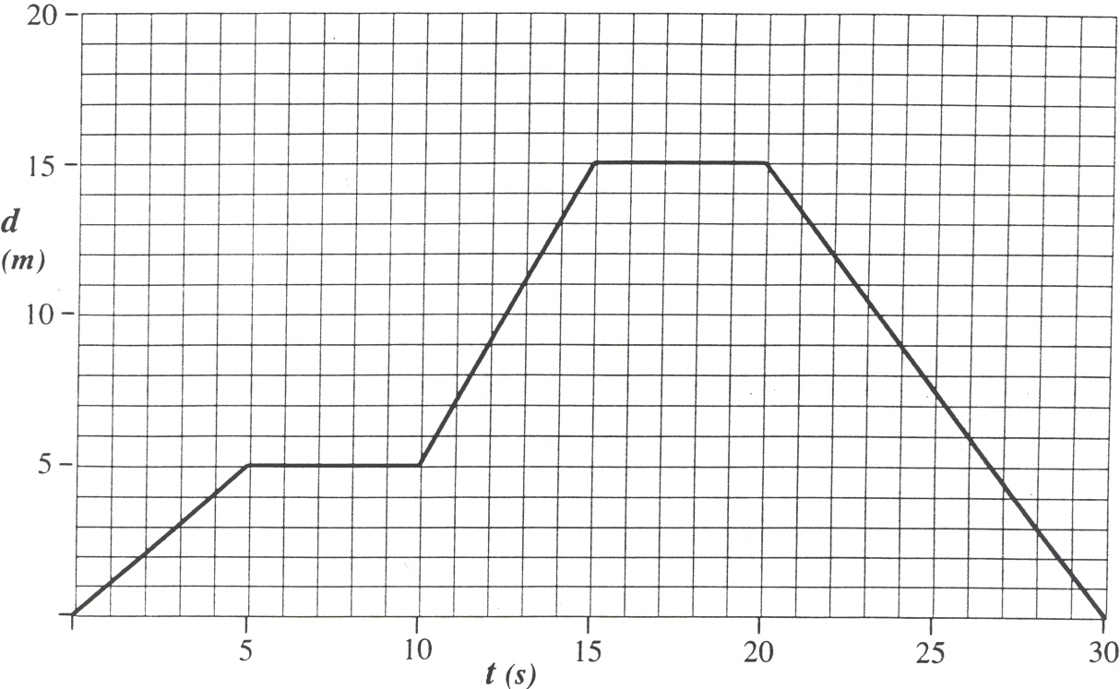
x
(m)
- How far does the object travel during the first 5 seconds (1 to 5 s)?

- How far does the object travel during the second 5 seconds (5 to 10 s)?

- How far does the object travel during the third 5 seconds (l0 to 15 s)?

- How far does the object travel du ring the fourth 5 seconds (15 to 20 s)?

- How far does the object travel during the last 10 seconds (20 to 30 s)?

- During which time interval(s) is the object standing still?

- How fast is the car moving during the first 5 seconds?

- How fast is the car moving during the last 10 seconds?

Sketch the distance-time graphs and speed vs. time graphs for each of the following scenarios. Explain your sketches.

- An elevator that ascends from the lobby to the 36th floor, stops, descends to the 27th floor, stops, and returns to the lobby.
x
v

- A basketball is dropped (vertically) on the court and allowed to bounce up and down several times undisturbed.
x
v

- A car on a test track performing a zero-to-sixty acceleration test.

v
x

