Mousetrap Car Graphing Instructions

- Open Google Sheets and create a new file.
- In the first column plot the time, and distance in the second column
- Once you have at least 4 points inputted, then highlight the two columns
- Click the chart buttonand select scatter plot.
- The graph should appear with your labels.
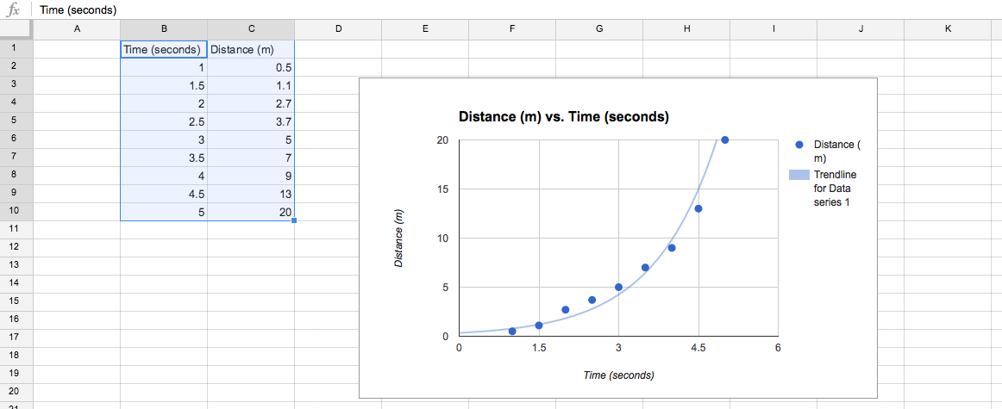
- Click on one of the points on your graph and select a best fit line for your points.
Getting the Speed
- For the average speed, use the point at the beginning, and end of your graph to get the average slope over the whole race.

The Mousetrap Car Report
Answer questions on a separate sheet of paper. Show all work and answer in complete sentences. Staple all graphs to your report.
1. Explain your group's thought process when creating the design of your car. Why did you pick your shape, materials and size?
2. What is the advantage to using small vs. large wheels in this speed race?
3. Make a position vs. time graph of your mousetrap (there must be at least 4 data points).
4. Explain how you find the average speed of your car from your graph above.
5. Convert the speed of your car to centimeters/minute, and miles/hour.
6. Use your position vs. time graph to make a speed vs. time graph.
7. Use this graph to get the average acceleration of your car and explain how you did this.
8. On your position graph, draw and label the following motions and explain how you determined these lines:
a) car moving at a constant speed faster than your car.
b) car moving at a constant speed slower than your car.
c) car that starts off slow and gets faster towards the end.
d) car that starts off fast and ends slow.
f) car that only gets to the 2 meter mark, and stays there for 4 seconds.

