Mousetrap Car Graphing Instructions

- Open Google Sheets and create a new file.
- In the first column plot the time, and distance in the second column
- Once you have at least 4 points inputted, then highlight the two columns
- Click the chart buttonand select scatter plot.
- The graph should appear with your labels.
- Click on one of the points on your graph and select a best fit line for your points. 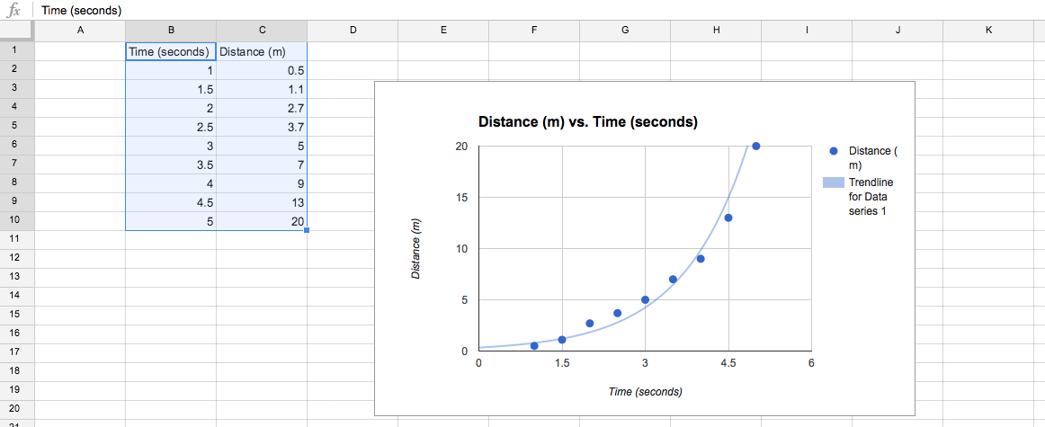
Getting the Speed
- For the average speed, use the point at the beginning, and end of your graph to get the average slope over the whole race.
- To make a speed vs. time graph use the

The Mousetrap Car Report
Answer questions on a separate sheet of paper. Show all work and answer in complete sentences. Staple all graphs to your report.
1. Explain your group’s thought process when creating the design of your car. Why did you pick your shape materials and size?
2. What is the advantage to using small vs. large wheels in this speed race?
3. Make a position vs. time graph of your mousetrap car during the race. There must be at least 4 points.
4. How do you find the average speed of your car from your graph above?
5. Use your graph to determine at what spot is your car moving the fastest.
6. Use your position vs. time graph to make a speed vs. time graph.
6. On your position vs. time graph add on these lines in different colors, and label which one is which.
- Car moving at a constant speed, faster than your car
- Car moving at a constant speed, slower than your car
- Car that starts off slow and gets faster towards the end
- Car that starts off fast and ends slow
- Car that only gets to the 2 meter mark and stays in the same spot
7. Discuss the major problems encountered in the performance of your vehicle and what did you do to solve them.

