Scientist: __________________________________ Per: _________ Date: __________

Answer the series of questions using the following position-time graph.
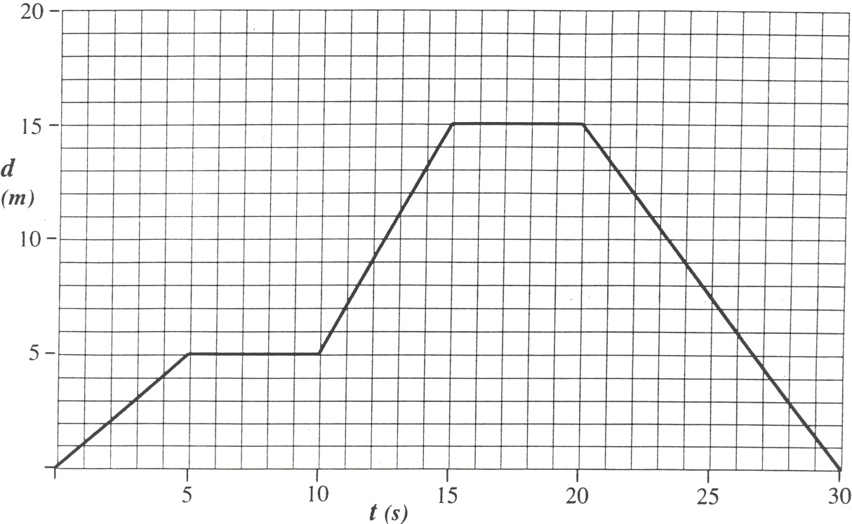
x
(m)
- How far does the object travel during the first 5 seconds (1 to 5 s)?
___________________
- How far does the object travel during the second 5 seconds (5 to 10 s)?
___________________
- How far does the object travel during the third 5 seconds (l0 to 15 s)?
___________________
- How far does the object travel du ring the fourth 5 seconds (15 to 20 s)?
___________________
- How far does the object travel during the last 10 seconds (20 to 30 s)?
___________________
- During which time interval(s) is the object standing still?
___________________
- Does the car ever accelerate in this scenario?
___________________

Sketch the distance-time graphs for each of the following scenarios. Explain your sketches.

- An elevator that ascends from the lobby to the 36th floor, stops, descends to the 27th floor, stops, and returns to the lobby.

- A basketball is dropped (vertically) on the court and allowed to bounce up and down several times undisturbed.

- A car on a test track performing a zero-to-sixty acceleration test. (This acceleration will not be uniform.)

