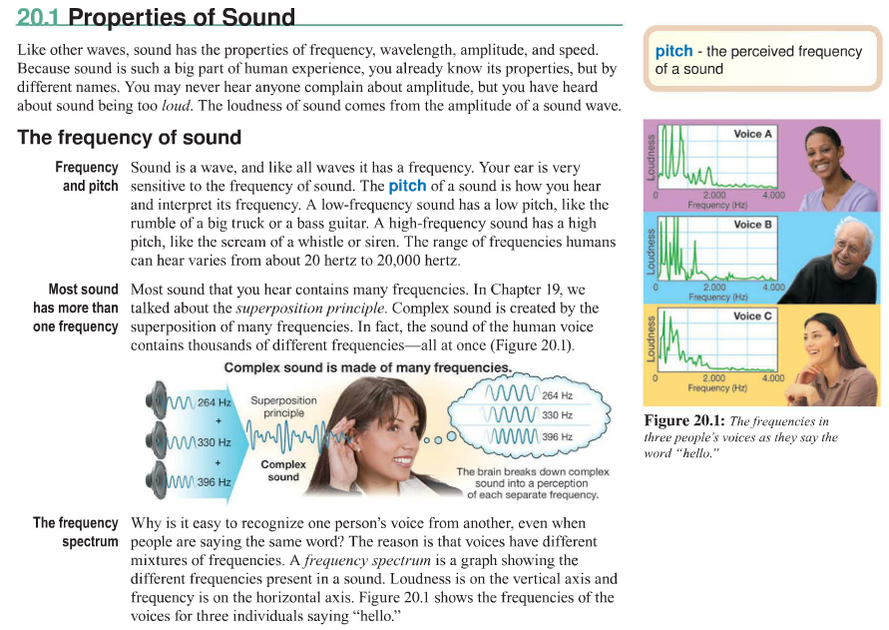
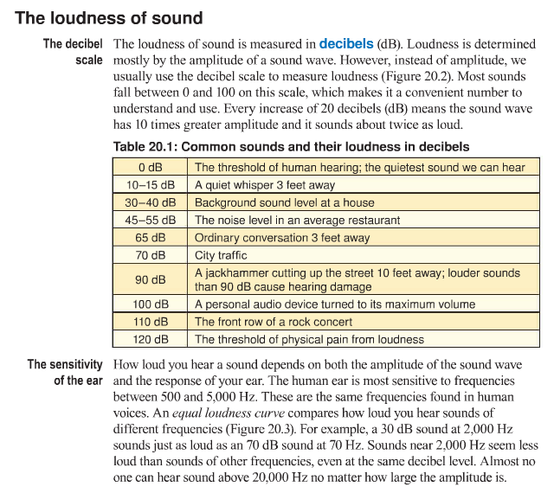

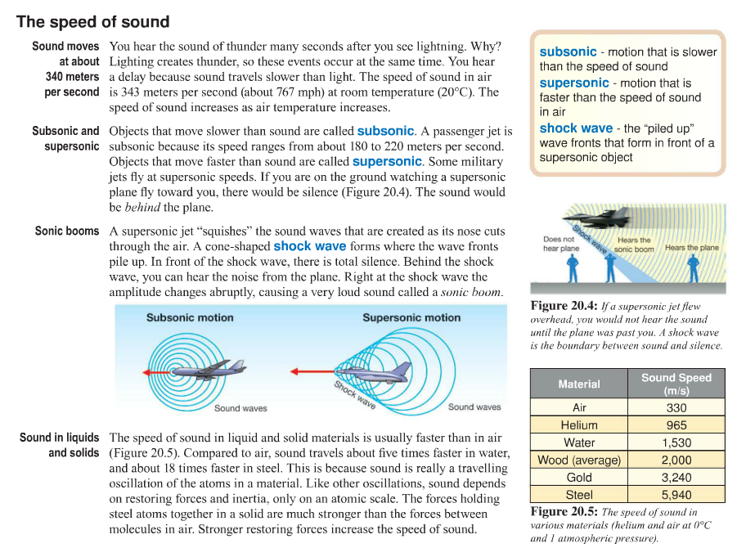
Diagram Review: Look through the diagrams and pictures and select the most interesting one. Why do you find it interesting? What is the picture or diagram trying to show? How does the picture help you understand this chapter?

Text Review: Record new words, important phrases or concepts/ other notes. You MUST fill up the whole space below with notes.

