Interference
Sound waves produced from different sources at the same time interfere with each other. The graphs below shows examples of constructive interference and destructive interference. Study the graphs carefully. Then, answer the questions that follow.
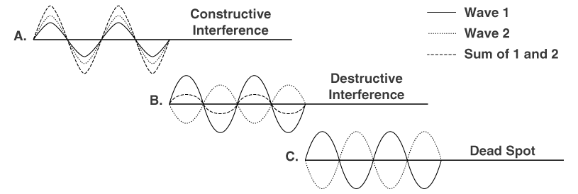

- What type of interference is each graph?
A)
B)
C)
- In Graph A, how does the amplitude of the sum compare with the amplitudes of waves 1 and 2?

- Look at Graph B. What would happen to the sound when the two waves interfere?

- In Graph B, how does the amplitude of the sum compare with the amplitudes of waves 1 and 2?

- When the crests and troughs of two waves occur at the same time, the waves are said to be in phase. What type of interference do you think this is called? Draw an example of this happening.

- Describe the kind of interference that results when two waves are not in phase. What type of interference do you think this is called? Draw an example of this happening.

- A special case of destructive interference is shown in Graph C. Based on Graph C, what is a dead spot? How do you think a dead spot is produced?
