Friendship Detector!

Purpose: To design a complex circuit (uses both parallel and series) that in the end will light up if a person passes the friendship detector test.

Requirements: There must be 5-7 questions in your circuit
Each question uses binary conditions (clear right and wrong answer)
There must be at least one “OR” statement and one “AND” statement
--In addition to the circuit diagram, you need to write out each question and the sequence in the circuit
Designs must be approved before you can get your materials
All questions must be school appropriate.

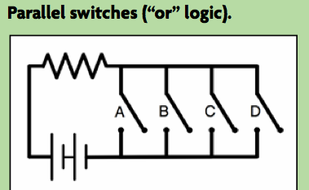
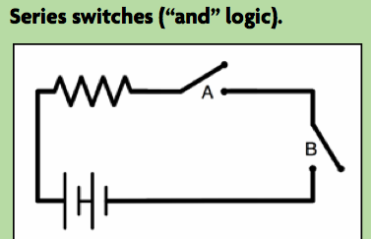
Examples:

Friendship Detector!

Purpose: To design a complex circuit (uses both parallel and series) that in the end will light up if a person passes the friendship detector test.

Requirements: There must be 5-7 questions in your circuit
Each question uses binary conditions (clear right and wrong answer)
There must be at least one “OR” statement and one “AND” statement
--In addition to the circuit diagram, you need to write out each question and the sequence in the circuit
Designs must be approved before you can get your materials
All questions must be school appropriate.

Examples:

Switch A: Do you like dogs?

Switch B: Do you like desserts? AND Switch C: Do you live nearby?

As long as the person likes dogs, the other switches do not matter.
But if not, then BOTH switch B and C need to be answered correctly in order to pass the detector.
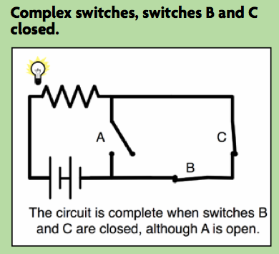
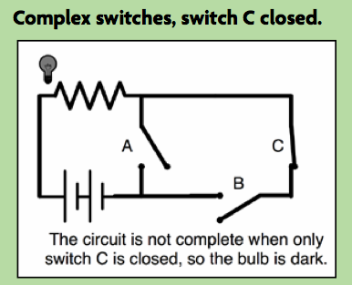
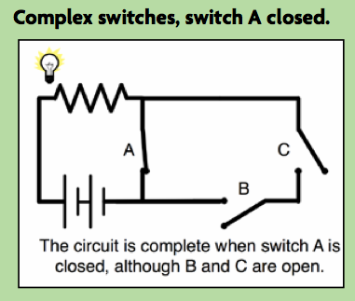

Switch A: Do you like dogs?

Switch B: Do you like desserts? AND Switch C: Do you live nearby?

As long as the person likes dogs, the other switches do not matter.
But if not, then BOTH switch B and C need to be answered correctly in order to pass the detector.

