Scientist: _____________________________________________________________ Per: ____________ Date: ______________

Energy Quiz 2 ESK 4.1
PE=mgh KE=$\frac{1}{2}mv^{2}$ g= 9.8m/s²

1) Use the roller coaster image below to compare the amounts of Potential Energy, Kinetic Energy and Total Energy at each of the 4 labeled locations. Assume there is no friction involved. ALSO describe the speed at each spot (where it is going fast, medium and slow). Don’t forget to explain WHY and HOW you know this!

Location 1)

Location 2)

Location 3)

Location 4)

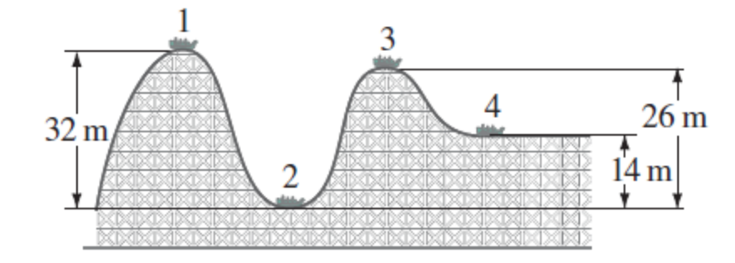
ESK 4.2
- A boy rides a bike. He has a mass of 90 kg. The hill he rides down has a height of 10 m. Find his potential energy, kinetic energy, and total energy at the points shown below.

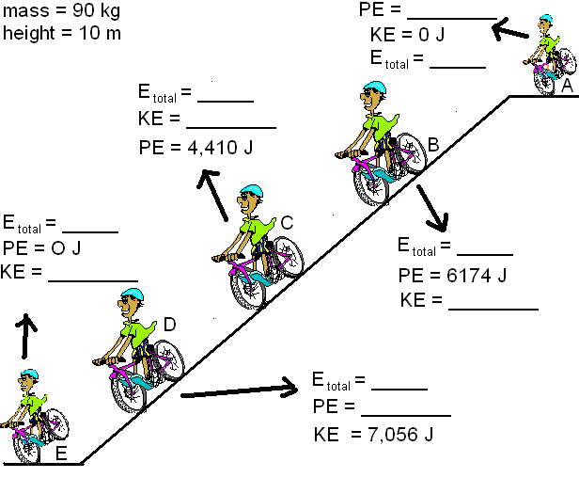

2) A bug of mass .02 Kg is flying at a speed of 2 m/s and a height of 5 meters in the air. What is the total energy of the bug?

To get Mastered:
A 4kg ball starts from rest and rolls down a hill. At the bottom of the hill the ball has a kinetic energy of 50 J. What was the height of the hill?

