Scientist_____________________________________________________ Per_______ Date___________________
My Role _________________________________________________
Group Members_______________________________________________________________________________

Lab2: Trebuchet Measuring

I. Purpose/Question
- To measure the distance a trebuchet can fire a projectile in centimeters then convert.
- To measure the mass of the trebuchet counterweight in grams and convert.
- To be able to predict the distance a projectile will travel based on the force, using a graph.

II. Theoretical
Trebuchet: a machine that uses counter weights, used in medieval siege warfare for hurling large stones or other missiles. In Medieval times, trebuchets would use weights up to 110 kg and their projectiles could fly as far as 61 meters!
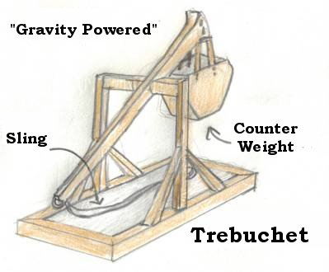
Distance: The unit of length between two points usually measured in meters or cm
Mass: A measure of the matter in an object usually measured in grams.
Projectile: Any object that is thrown or launched and eventually drops to the ground.

Materials
- Meter stick
- Trebuchet
- 3 washers
- 2 Clay projectiles
- Scale
III. Procedure
- Grab the first 4 materials listed and bring them back to the group.
- Get the mass of 1 washer, 2 washers, and 3 washers. Record on data table in grams.
- Hook 1 washer on the trebuchet and fire your projectile 3 times. Record the distance that your projectile flies each time in centimeters. Record the distance from the end of the trebuchet until the spot that the projectile first hits the floor.
- Repeat Step Three with 2 washers (3 trials) and again with 3 washers (3 trials)
- Take the average of all three trials. (Add trials together and divide by 3)
- Convert all units in the analysis questions.
- Get a piece of graph paper, create a graph of mass (g) vs. distance (avg cm)

IV. Analysis

# of Washers | Mass of Washers in Grams | Distance of Projectile in centimeters
1 |  | ^{Trial 1}
 |  | ^{Trial 2}
 |  | ^{Trial 3}
 |  | ^{AVERAGE}
2 |  | ^{Trial 1}
 |  | ^{Trial 2}
 |  | ^{Trial 3}
 |  | ^{AVERAGE}
3 |  | ^{Trial 1}
 |  | ^{Trial 2}
 |  | ^{Trial 3}
 |  | ^{AVERAGE}
4  (only if you have extra time) |  | ^{Trial 1}
 |  | ^{Trial 2}
 |  | ^{Trial 3}
 |  | ^{AVERAGE}
- Convert the mass of the counterweights from grams to the other 3 major metric units for mass.

 | Mass of Trebuchet Counterweights (Washers)
 | Grams (from lab) | Centigrams | Milligrams | Kilograms
1 washer
2 washers
3 washers
- Using the average for your trials, convert the measured distances from centimeters to the other 3 major metric units for distance

 | Distance of Projectile
 | Centimeters (from lab) | Meters | Millimeters | Kilometers
1 washer (average distance)
2 washers (average distance)
3 washers (average distance)
V. Conclusion In composition book answer in paragraph form.

- Restate the purpose.
- Explain what you got for your results.
- Do these results make sense? Use your graph to explain why they do/don’t make sense (If they DON’T make sense, then what SHOULD have happened?)
- Use your graph to predict how much mass you must put on for the projectile to go: 100cm, 160cm, 500cm. Explain how you figured this out.
- What could you have done next time to make your results better?

