Warm Up pg 32
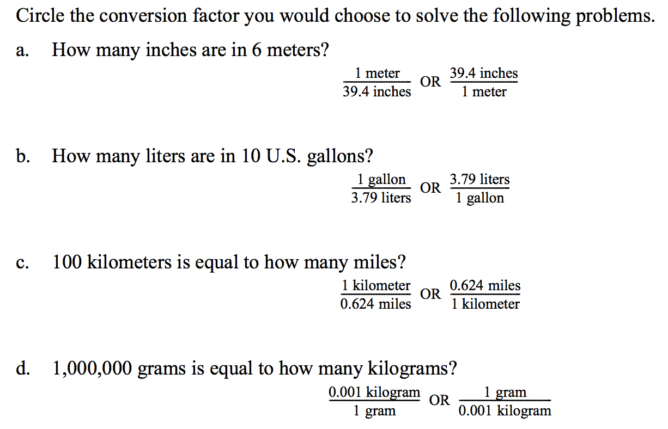

Warm Up pg 32

Fill in the blank of the missing unit. Show work for all canceled out units
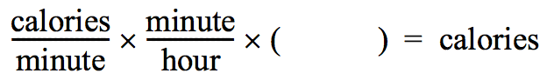
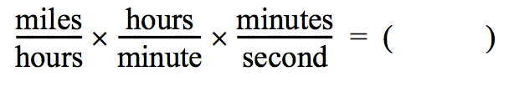
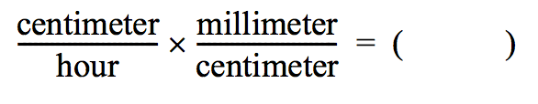
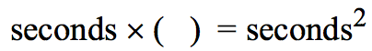
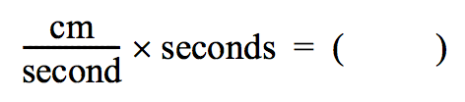
Fill in the blank of the missing unit. Show work for all canceled out units

