Scientist: ___________________________________________ Period:_______________ Date:_____________
Student Score: 1 2 3 4

Actual Score: 1 2 3 4
Assessment 1.1 A

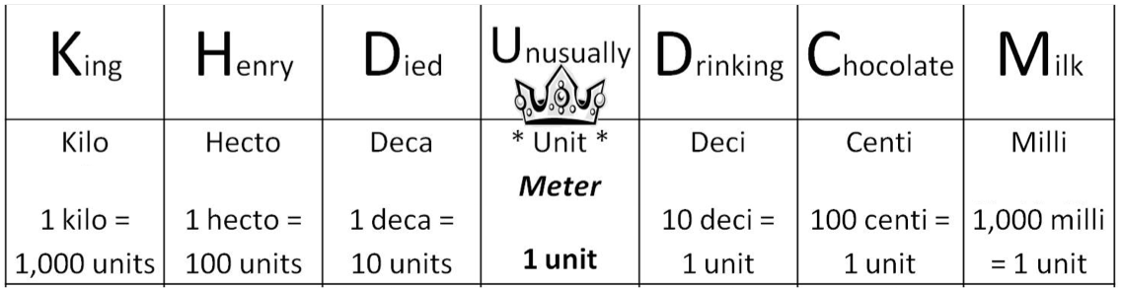

5280 feet = 1 mile
1 mile = 1609 meters
12 inches = 1 foot
1000 grams = 1 Kilogram
1 pound = .4 Kilogram
1 pound = 453 grams
1 mile = 1.6 Km
1 month = 30 days
60 seconds = 1 minute
60 minutes = 1 hour
24 hours = 1 day
1 year = 365 days

- If you were converting 42 meters into kilometers, which fraction would you use as a converting factor?
A)  $$\frac{1000 meters}{1 km}$$ | B)  $$\frac{1000 km}{1 meter}$$ | C)  $$\frac{1 km}{1000 meters}$$ | D)  $$\frac{1 meter}{1000 km}$$
Explain your reasoning:

- Usain Bolt is the world champion in the 200 meter race, how many miles is that?

- We have 8.4 months of school left, how many days is class is that?

- A cheetah can run 27 m/s how fast is that in km per hour?

- Ms. Hannouche is taking a trip down to San Diego and is driving on the freeway at 65 miles/hour. If San Diego is 107 miles away, how long does it take her to get there?

Scientist: ___________________________________________ Period:_______________ Date:_____________
Student Score: 1 2 3 4

Actual Score: 1 2 3 4
Assessment 1.1 B

5280 feet = 1 mile
1 mile = 1609 meters
12 inches = 1 foot
1000 grams = 1 Kilogram
1 pound = .4 Kilogram
1 pound = 453 grams
1 mile = 1.6 Km
1 month = 30 days
60 seconds = 1 minute
60 minutes = 1 hour
24 hours = 1 day
1 year = 365 days

- If you were converting 42 meters into kilometers, which fraction would you use as a converting factor?
A)  $$\frac{1000 km}{1 m}$$ | B)  $$\frac{1000 meter}{1 km}$$ | C)  $$\frac{1 meter}{1000 km}$$ | D)  $$\frac{1 km}{1000 meters}$$
Explain your reasoning:

- We have 8.4 months of school left, how many days is class is that?

- Usain Bolt is the world champion in the 200 meter race, how many miles is that?

- A cheetah can run 27 m/s how fast is that in km per hour?

- Ms. Hannouche is taking a trip down to San Diego and is driving on the freeway at 65 miles/hour. If San Diego is 107 miles away, how long does it take her to get there?

Scientist: ___________________________________________ Period:_______________ Date:_____________
Student Score: 1 2 3 4

Actual Score: 1 2 3 4
Assessment 1.1 Accom.

- If you were converting 42 meters into kilometers, which fraction would you use as a converting factor?
A)  $$\frac{1000 meters}{1 km}$$ | B)  $$\frac{1000 km}{1 meter}$$ | C)  $$\frac{1 km}{1000 meters}$$ | D)  $$\frac{1 meter}{1000 km}$$
Explain your reasoning:

- Usain Bolt is the world champion in the 200 meter race, how many miles is that?
1 mile = 1609 meters

$$\frac{200 meters}{1 km}$$ | $$\frac{10 00 km}{1 meter}$$ | $$\frac{ miles}{1000 meters}$$

- We have 8.4 months of school left, how many hours until the end of the year?
1 month = 30 days
1 day = 24 hours
$$\frac{27 meters}{second}$$ | $$\frac{1 km}{1000 meters}$$ | $$\frac{1 km}{1000 meters}$$ | $$\frac{1 km}{1000 meters}$$ | $$\frac{ km}{ hour}$$
- A cheetah can run 27 m/s how fast is that in km per hour?
1 minute = 60 seconds
60 minutes = 1 hour
1 km = 1000 meters
$$\frac{hour}{65 miles}$$ | $$\frac{1 km}{1000 meters}$$ | $$\frac{ hours }{1000 km}$$

$$\frac{8.4 months}{}$$ | $$\frac{1000 km}{1 meter}$$ | $$\frac{1 km}{1000 meters}$$ | $$\frac{ hours}{1000 km}$$
- Ms. Hannouche is taking a trip down to San Diego and is driving on the freeway at 65 miles/hour. If San Diego is 107 miles away, how long does it take her to get there?

