Scientist_______________________________________________Date_______Period______

Circuits Review

Solve the following problems using Ohm’s Law (V = IR)

1. If the current is 14 Amps and the resistance in a circuit is 4 Ohms, what must the voltage be?

2. If the current in a circuit is 12 Amps, and the resistance is 4 Ohms, what is the Voltage?

3. What is the resistance of the light bulb?
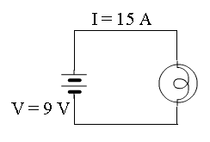

4. A 10 voltage power source provides a current through a 20 Ω resistor. What is the current through the circuit?
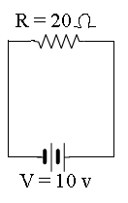

5. A lamp is connected to a 7 volt battery. The current traveling through the circuit is 2 A. What is the resistance in the light bulb

6. Explain what electric current is in your own words.

7. What things need to be present to make a complete circuit?

9. What is an easy way to tell if a circuit is a parallel or a series circuit? Draw an example of each, and label them with either series or parallel.

10. Describe what voltage is in your own words. Draw a picture to describe if it helps you to describe it

11. Describe what a resistor is in your own words. Draw a picture to describe if it helps you to describe it.

12. Create a cartoon that demonstrates how current flows in a circuit. Each part of the circuit has a specific job. Your comic should demonstrate the job that each parts has and what would happen if one part went missing.

