Did you kill Hae Min Lee Detector!?

Purpose: To design a complex circuit (uses both parallel and series) that in the end will light up if a person passes the “Did you kill Hae Min Lee Detector?”.

Requirements: There must be 6-7 questions in your circuit
Each question uses binary conditions (clear right and wrong answer)
There must be at least one “OR” statement and one “AND” statement
--In addition to the circuit diagram, you need to write out each question and the sequence in the circuit
Designs must be approved before you can get your materials
All questions must be school appropriate.

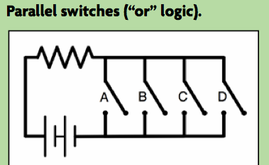
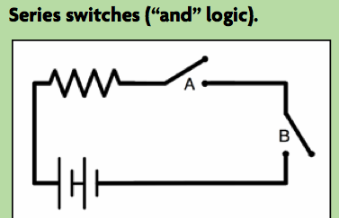
Examples:

Did you kill Hae Min Lee Detector!?

Purpose: To design a complex circuit (uses both parallel and series) that in the end will light up if a person passes the “Did you kill Hae Min Lee Detector?”.

Requirements: There must be 6-7 questions in your circuit
Each question uses binary conditions (clear right and wrong answer)
There must be at least one “OR” statement and one “AND” statement
--In addition to the circuit diagram, you need to write out each question and the sequence in the circuit
Designs must be approved before you can get your materials
All questions must be school appropriate.

Examples:

Switch A: Do you own a shovel?

Switch B: Were you with Jay the afternoon of January 13, 1999? AND Switch C: Were you at track practice for the entire duration on January 13, 1999?

According to this test, if the person owns a shovel then they are guilty.
But if not, then BOTH switch B and C need to be answered correctly in order to pass the detector.
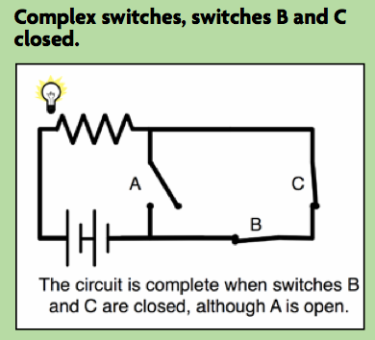
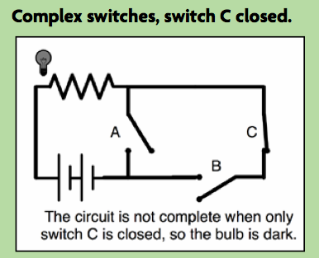
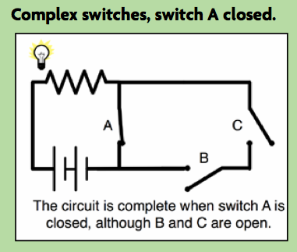

Switch A: Do you own a shovel?

Switch B: Were you with Jay the afternoon of January 13, 1999? AND Switch C: Were you at track practice for the entire duration on January 13, 1999?

According to this test, if the person owns a shovel then they are guilty.
But if not, then BOTH switch B and C need to be answered correctly in order to pass the detector.

