Engineering Challenge
Instructions: In your Exhibition groups you have one day to construct an Earthquake resistance building using the materials listed below. The following guidelines must be followed then building your structure.
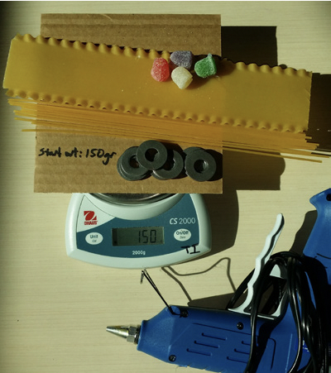
    - Before building your structure, weigh the following allotted materials and record the mass directly on the cardboard: a. Spaghetti (12pcs), b. Lasagna (1.5pcs) c. Gumdrops (4pcs), d. Cardboard base e. 8 washers.
    - After the structure is built, re-weigh all of your materials again before the final testing. This mass is to be recorded on the cardboard too.
    - The difference, due to the use of glue, can’t be more than 7 grams! (1.5 glue sticks) Write this difference on the cardboard!
- The structure can only be built on the cardboard base. This base represents your “property” which you can build upon. Nothing hanging over the edge of the cardboard. Except for the cardboard base, each successive floor must be made of lasagna, but the lasagna can be used for more than just flooring. (The cardboard base is considered the bottom or 1st floor).
Each floor must be separated from the other floors by a minimum of 10 cm. Only floors separated by at least 10 cm of clearance will be counted for points.
Only 4 gumdrops can be used in your structure. a) Gumdrops works well as your foundation (to hold the spaghetti on to the base). b) Gumdrops do not have to be used “whole.”

Materials:
- A piece of Cardboard
- 12 pieces of full length spaghetti
- 1.5 pieces of lasagna noodle
- Glue -7 grams at most
- 4 gumdrops
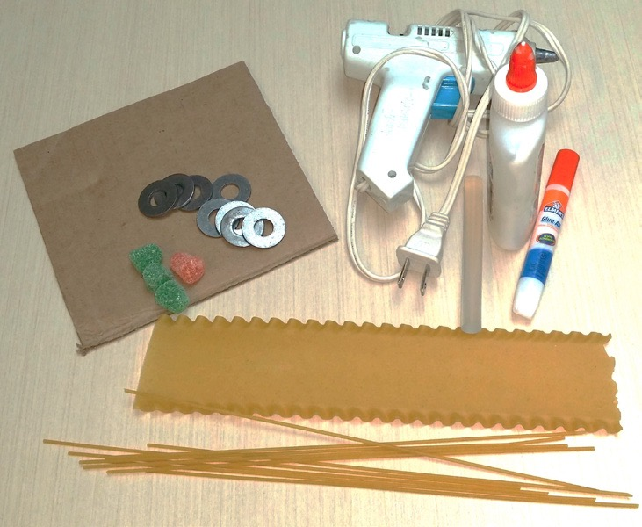
- 8 washers

Structural engineering:
Because earthquakes send huge forces through a building, Engineers incorporate a variety of design features into their structure. These design techniques may help your building withstand damage and collapse. Structural design should play a factor in your building. Here are some questions to consider when putting together your structure.
How should you connect your pasta (structural members)?
What geometries/shapes should you use?
Would making connections meet at right angles or other angles be better?
Would cross-bracing help?
Should the pieces of pasta be long or short?
What should be the size of your base? Narrow or wide?
How much of your limited glue should you use and where?
This is a challenge: Do you want to merely survive the challenge or win it? Should you push the limits of the design constraints? Do you want to take risks with your design (be innovative) or be more conservative in your design? You will “win” more points in this challenge if you approach the structure’s limits.
  - It is recommended that 5 grams are used for the structure and 2 grams are used to secure the washers to the structure.
- Washers can be thought of as occupants or rent paying tenants and will help add to your team’s point total.
- a) There is a limit of 8 washers
- b) Washers cannot overlap
- c) Washers must be all on a floor (no bits hanging over the edge).
- d) Washers on higher floors count for more points (higher rent)
- e) Washers must be glued down,
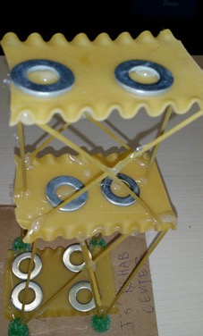

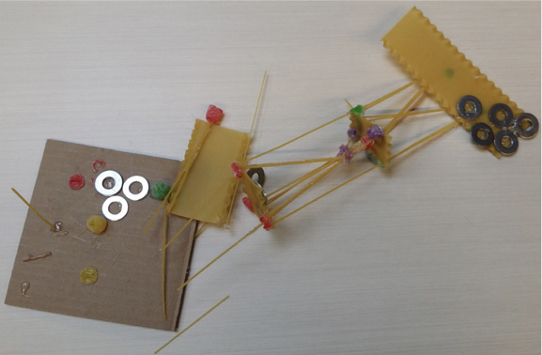

Engineering Structure Rubric
