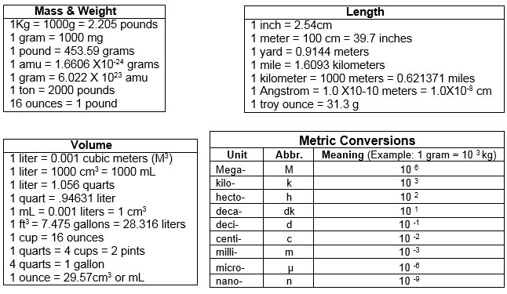**Dimensional Analysis Guide**

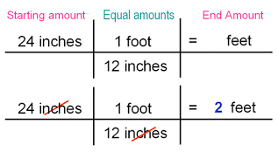

**Dimensional Analysis Guide**



