Scientist: Per: Date:

Series and Parallel Circuits Reading
A circuit is the path followed by an electric current.1 A circuit is made up of three parts. The first part is an energy source, such as a battery or generator.2 The second part is an energy recipient,3 such as a motor or lamp. The third part is a connection, such as a wire or cable that carries energy from the source to the recipient. There are two basic types of circuits: series circuits and parallel circuits.
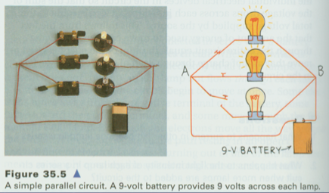
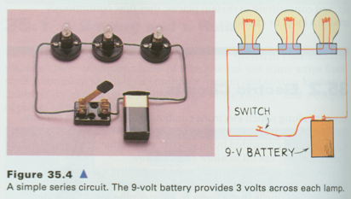
Series circuits are easy to understand if you think about old Christmas lights, or any strand of light bulbs linked to each other. What happens if one bulb goes out on the strand of lights? They all go out. This is because in a series circuit the energy has to go through one recipient to get to the next. If a bulb blows out, the energy stops at that bulb. It never makes it to the next bulb. This means that the current and voltage going through all of the bulbs is the same for the whole circuit. The caption to the picture explains that the voltage is shared by the bulbs in a series circuit.
A parallel circuit can be more efficient than a series circuit. Energy is passed through both the recipients and through a second connection. As long as there’s an energy source, electricity will always be able to reach each recipient. If there is a problem with one recipient, the other recipients are not affected. This means that all of the bulbs are getting the full 9 volts of the battery. The current might be different for each strand based on the resistance of each bulb.

In practice, almost all electrical devices have complex circuits. Complex circuits do not use just one type of circuit. Instead, complex circuits utilize a combination of both series and parallel types. Devices that use complex circuits include computers and television sets.

1. According to this passage, what is the second part of a circuit?
- Electric current
- Energy source
- Energy recipient
- Generator

2. The primary purpose of this passage is to describe
- How Christmas lights work
- How different types of circuits work
- What complex circuits are
- The types of circuits found in computers

3. What would happen if one light went out in a parallel circuit?
- All of the lights would go out.
- All the lights except for that one would stay lit.
- The energy source would stop working.
- The circuit would become a simple circuit.

4. Read these sentences: “Complex circuits do not use just one type of circuit. Instead, complex circuits utilize a combination of both series and parallel types.”
The word utilize means
a. To make use of
b. To provide energy for
c. To create
d. To burn out

5. What role do the two diagrams play in the passage?
- They illustrate two types of circuits that are described in the text of the passage.
- They contradict the information described in the text of the passage about series and parallel circuits.
- They illustrate how series and parallel circuits combine to form a complex circuit.
- They illustrate information about circuits not discussed in the text of passage.

6. How is energy passed in a parallel circuit?

7. What evidence from this passage could support the idea that a strand of lights might benefit from using a parallel circuit instead of a series circuit?

8. Read the following sentence.
Complex circuits use a combination of both series and parallel types in devices like television sets.
Answer the questions below based on the information provided in the sentence you just read.

What do complex circuits use?

Where are they used?

9. If the voltage to each bulb on a series circuit is less than a parallel circuit, what does that mean about the brightness of the bulbs in a series?

10. Vocabulary Word: efficient (adj.): able to work successfully without wasting time or energy.

Use the vocabulary word in a sentence:

