Scientist: Per: Date:

Circuit Simulation

- Play around with the simulation and see what kind of circuits you can build.

- Write at least 1 thing that you discovered:

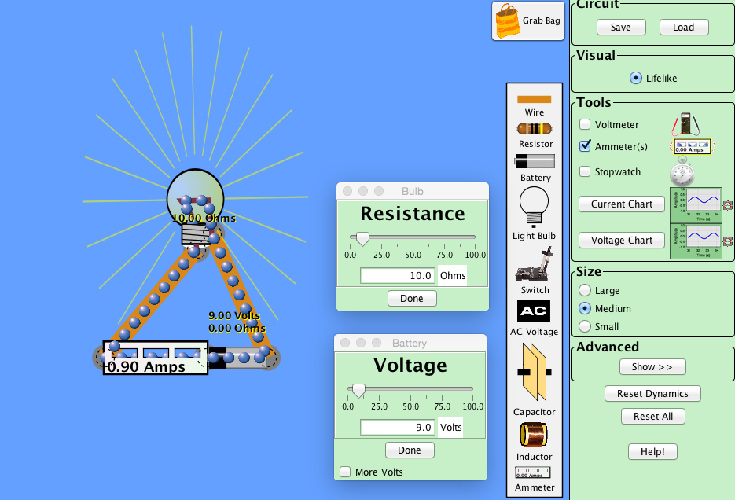
- Setup your circuit to look like this:

- See what happens to the current when you increase or decrease the resistance, and the voltage. Change them ONE at a time, and record them on the table below. (Use whole numbers!)
Voltage -V  (Volts) | Resistance -R  (Ohms) | Current -I  (Amps)
9 Volts | 10 Ohms | .9 Amps
9 Volts
9 Volts
9 Volts
9 Volts
9 Volts

Voltage -V  (Volts) | Resistance -R  (Ohms) | Current -I  (Amps)
9 Volts | 10 Ohms | .9 Amps
 | 10 Ohms
 | 10 Ohms
 | 10 Ohms
 | 10 Ohms
 | 10 Ohms

- If you increase the Voltage, what happens to the Current?

- If you increase the Resistance, what happens to the Current?

- On the back, graph Voltage and Resistance Vs. Current

- Circle the equation that makes the most sense:

- I = VR I = $\frac{V}{R}$ I = $\frac{R}{V}$

Build 1-3 “crazy circuits” (You can use multiple batteries, lights or any items from the grab bag) Draw your circuits below.

Series Parallel

