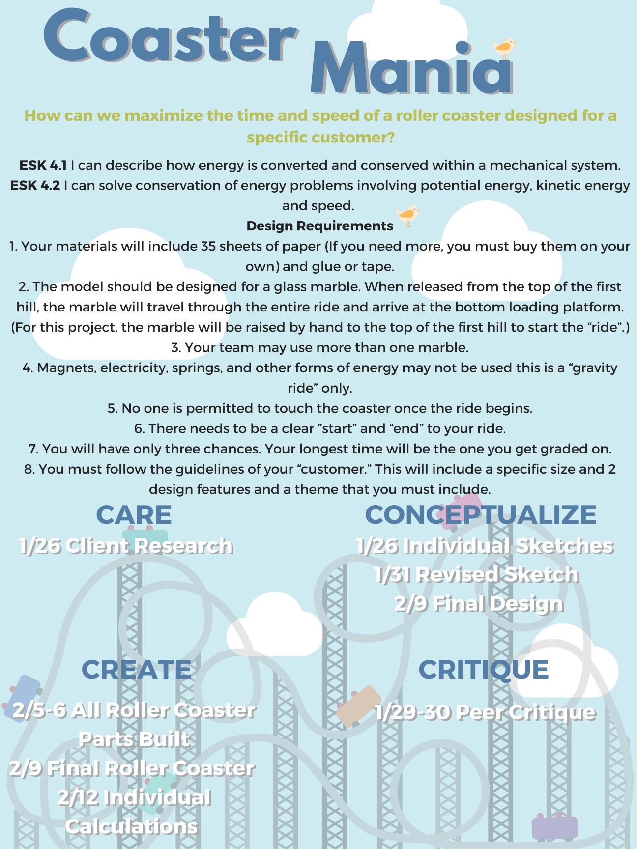

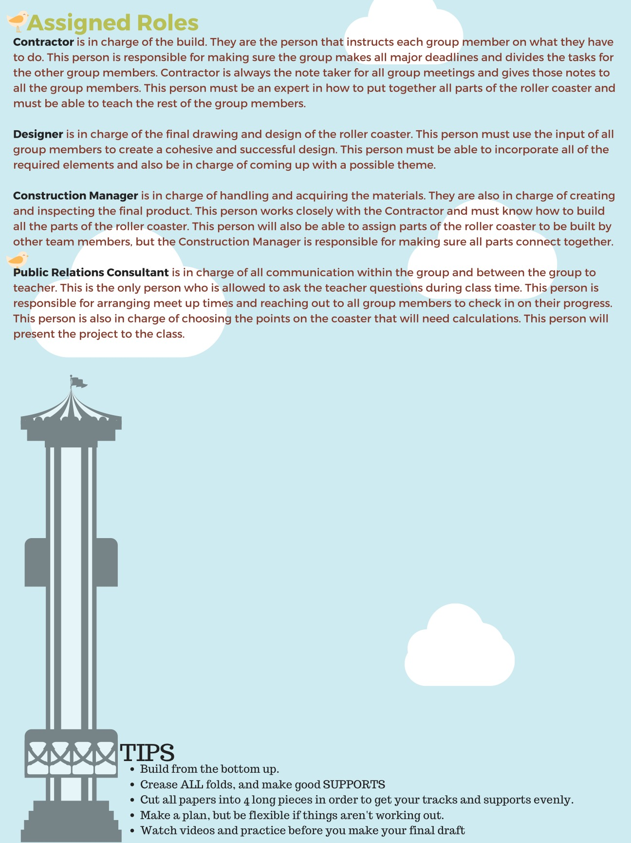

 | 4 | 3 | 2 | 1
ESK 4.1 I can describe how energy is converted and conserved within a mechanical system | Written explanation is clear and fully explained. Explanation uses specific examples of your roller coaster to explain conservation of energy | Written explanation is clear and fully explained. | Explanation is correct by not clear and may skip a few important vocab terms. | Explanation is unclear or does not answer the prompt.
ESK 4.2 I can solve conservation of energy problems involving potential energy, kinetic energy and speed. | All calculations made by the group are correct and make sense. All calculations are clearly labeled on diagram with bar graphs and pie charts. | All calculations made by the group are correct and make sense. Some calculations are clearly labeled on diagram with bar graphs and pie charts. | One or more calculations are missing or inaccurate. Some answers may not make sense or there are missing pie charts or bar graphs. | More than 2 calculations are missing or inaccurate. It is not clear where the calculations take place.
Timing** | 30 + seconds | 24-29 seconds | 19-23 seconds | <19 seconds
Design | Design is thoughtfully created with the client’s ideas in mind. Design uses transformation of energy to create an exciting roller coaster to ride. | Design is thoughtfully created with the client’s ideas in mind. Ride could be faster or more exciting for riders. | Design does not completely connect with the client OR ride is not very exciting. | Design is not cohesive or doesn’t work. Ride has to be intervened by the builders.
Client Restrictions | All client requirements are incorporated fully into the design. Design is all made out of paper. | All client requirements are incorporated, but some may be a side thought. Design is all made out of paper. | One of the requirements is missing OR there is an element not made from paper. | More than one requirements are not a part, OR it is exceeds the size requirement

** Bonus time will be added for a good theme up to +3 seconds

