Metric Math Mistake Muffed Mars Meteorology Mission
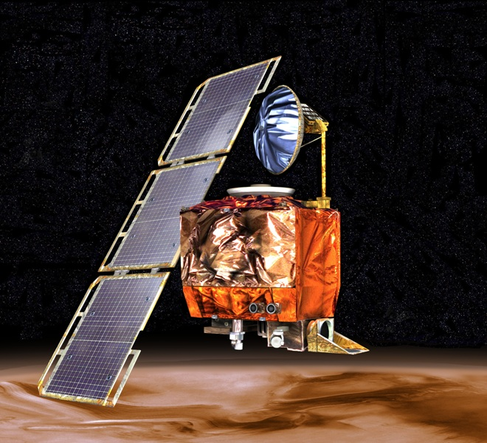
The Mars Climate Orbiter was a $125 million satellite that was designed to be first weather satellite to observe another world. Launched in December 1998, Orbiter approached Mars in September of 1999 after 9 months of travel. The Orbiter was supposed to study Martian climate, atmosphere and surface changes. But as it approached the red planet, the Mars Climate Orbiter suddenly vanished. Scientists realized quickly it was gone for good.
“It was pretty clear that morning, within half-an-hour, that the spacecraft had more or less hit the top of the atmosphere and burned up,” recalled NASA engineer Richard Cook, who was project manager for Mars exploration projects at the time.
A NASA review board found that the problem was in the software controlling the Orbiter’s thrusters. The software calculated the force the thrusters needed to exert in pounds of force. A separate piece of software took in the data assuming it was in the metric unit: newtons. One pound is equal to 4.4 newtons.
Due to this miscalculation, the Orbiter flew too close to Mars, and entered its atmosphere with disastrous results. The orbiter likely disintegrated in a fiery ball due to friction with Mars’ atmosphere, much like we might see a meteorite or shooting star streak across the night sky.
There had been warning signs. On the way to Mars, the spacecraft had to make 10 to 14 times more adjustments to the Orbiter’s course than engineers expected. And the last few signals from the Orbiter indicated that it was dipping dangerously low into the Martian atmosphere, about 105 miles lower than it was supposed to go.
Ultimately, the Mars Climate Orbiter came within 37 miles of the Martian surface. Simulations showed that, at any altitude lower than 53 miles, atmospheric friction would tear the fragile craft apart.
The whole thing could be written off as a miscommunication. Propulsion engineers, like those at Lockheed Martin who built the craft, typically express force in pounds, but it was standard practice to convert to newtons for space missions. Engineers at NASA’s Jet Propulsion Lab assumed the conversion had been made, and didn’t check.

Questions
- What is the Mars Climate Orbiter? What was it designed to do?

- What happened to the Orbiter?

- How did it happen?

- What lessons do you think NASA engineers might have learned from this mistake?

