Scientist: ____________________________________________
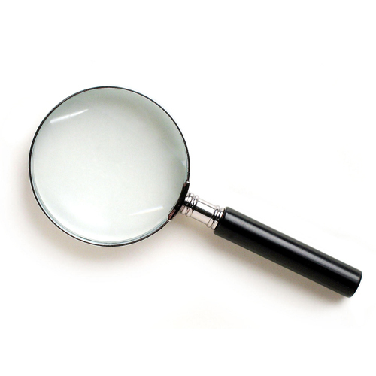
Syllabus Scavenger Hunt

- Name 3 different things that you need to bring to class everyday.
a.
b.
c.
- When is the last day to turn in any late assignments?

- When is the last day to re-do a major project or assessment?

- When do I have office hours?

Scientist: ____________________________________________
Syllabus Scavenger Hunt

- Name 3 different things that you need to bring to class everyday.
a.
b.
c.
- When is the last day to turn in any late assignments?

- When is the last day to re-do a major project or assessment?

- When do I have office hours?

- What will happen 1st if your cell phone is seen during class?

- What is the name of the type of grading we use?

- What e-mail address can you send e-mail to get in contact with Ms. Hannouche?

- What are the 4 classroom expectations?
a.
b.
c.
d.

- What will happen 1st if your cell phone is seen during class?

- What is the name of the type of grading we use?

- What e-mail address can you send e-mail to get in contact with Ms. Hannouche?

- What are the 4 classroom expectations?
a.
b.
c.
d.

