Scientist__________________________________________________ Period______ Date_____________________

PE and KE Matching

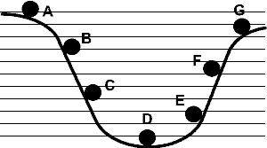
1. Which sequence correctly shows an increase in potential energy?
A. E, F, B, G B. B, F, E, C
C. D, E, B, F D. A, G, F, C

2. Which sequence correctly shows an increase in kinetic energy?
A. E, F, B, G B. B, F, E, C
C. D, E, B, F D. A, G, F, C

3. Which sequence correctly shows a decrease in kinetic energy?
A. E, F, B, G B. B, F, E, C
C. D, E, B, F D. A, G, F, C

Part 2: Determine whether the objects in the problems have kinetic, potential energy or both.

4. You serve a volleyball with a mass of 2 kg. The ball leaves your hand with a speed of 30 m/s. The ball has __________________ energy.

5. A box of pineapples is sitting at the top of a hill that is 21 m high. The box with the pineapples weighs 12 kg. The box has _________________ energy.

6. A car is traveling with a velocity of 40 m/s and has a mass of 1120 kg. The car has _______________ energy.

7. A cinder block is sitting on a platform 20 m high. It weighs 79 kg. The block has _______________ energy.

8. There is a bell at the top of a tower that is 45 m high. The bell weighs 190 N. The bell has ________________ energy.

9. A roller coaster is at the top of a 72 m hill moving at 50 m/s and weighs 966 N. The coaster (at this moment) has ________________ energy.

