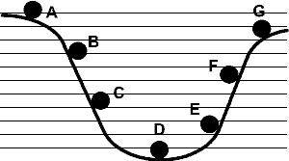
Label each number next to the correct letter on the diagram of the rolling ball.

1. Has the maximum kinetic energy
2. Has the maximum potential energy
3. Has the least potential energy
4. Has the least kinetic energy
5. Just a little more kinetic energy than A
6. Just a little more potential energy than C
7. Just a little less potential energy than F
8. Just a little more kinetic energy than G
9. Just a little less kinetic energy than D
10. Just a little less potential energy than C

