Scientist____________________________________________________ Per_______ Date___________________
Intro to Waves
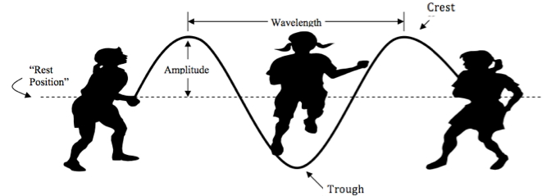
Crest-

Trough-

Amplitude-

Rest Position-

Wavelength-

Frequency-

Period-

1. If the girls move the rope up and down faster, what will happen to the wavelength?

2. How could the girls change the amplitude of the wave?
3. What would the girls need to do to make the period longer?

4. The picture below shows a wave. Re-draw this wave with twice the amplitude, and half the amplitude.

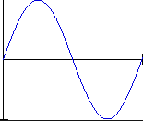

5. The picture below shows a wave with 1 Hz (1 wave per second). Draw a wave with 2 Hz and 3 Hz.
1 sec
1 sec
1 sec

6. Of the waves that you drew above, which one has the longest wavelength? Which one has the shortest?

7. If a wave has a frequency of 4 Hz (draw this out), how long does it take for the wave to make one complete cycle?
What is this cycle called?

8. In question 7, you found the period. What is the relationship between period and frequency?

A) period = $\sqrt{frequency}$ B) period = 1 C) period = (frequency)²
frequency

9. A wave has a frequency of 8 Hz. A) How many waves pass by each second? B) How many waves will pass by every ½ second? C) How long will it take for just one wave to pass by? Hint: use the equation from above.

10. A certain wave has a wavelength of 4 meters. If the frequency of the wave was 3 Hz, (then three complete wavelengths pass by a given point in one second.) How many meters of waves pass by a given point in one second?
Show work and DRAW and label.
A) 4 m B) 7m C) 12 m D) 1.25 m

11. Given your answer to question 10, what is the speed of the wave? (Remember that speed equals distance traveled divided by time, and the time was one second).

12. Consider a wave that has a wavelength of 5 meters. If the frequency was 4 Hz. Draw this wave and label everything that you know. How could you calculate the speed of this wave?

13. Based on your previous answers, what do you think is the relationship between wave speed (v), wavelength (λ), and frequency (f )? Explain
A) v = λ • f B) v = f a C) v = λ a
λ f

14. If a water wave vibrates up and down 3 times each second and the distance between wave crests is 2.5 meters.
a) Draw this wave.

b) what is the frequency of the wave?

c) What is the period?

d) What is the wavelength of the wave?

e) What is the speed of the wave?

