Scientist: Per: Date:

Circuit Simulation phet.colorado.edu Circuit Construction Kit: (DC) HTML5

- Go to the “LAB” tab. Play around with the simulation and see what kind of circuits you can build.

- Write at least 1 thing that you discovered:

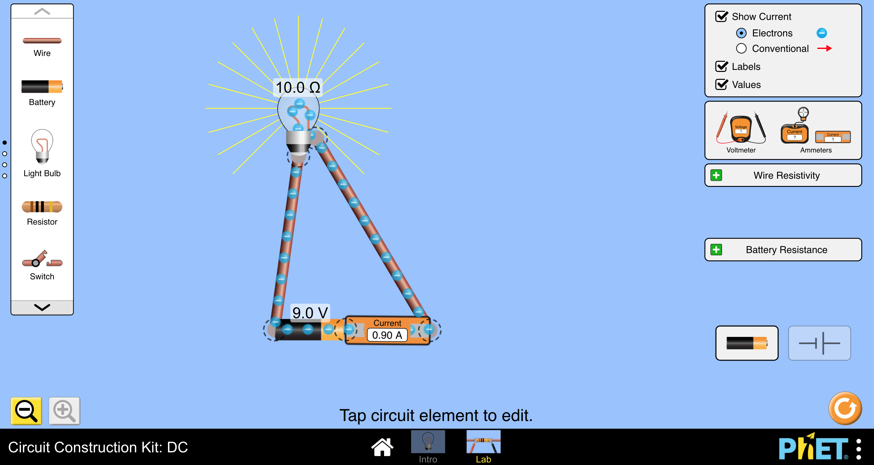
- Setup your circuit to look like this:

- See what happens to the current when you increase or decrease the resistance, and the voltage. Change them ONE at a time, and record them on the table below. (Use whole numbers!)
Voltage -V  (Volts) | Resistance -R  (Ohms) | Current -I  (Amps)
9 Volts | 10 Ohms | .9 Amps
9 Volts
9 Volts
9 Volts
9 Volts
9 Volts

Voltage -V  (Volts) | Resistance -R  (Ohms) | Current -I  (Amps)
9 Volts | 10 Ohms | .9 Amps
 | 10 Ohms
 | 10 Ohms
 | 10 Ohms
 | 10 Ohms
 | 10 Ohms

If you increase the Voltage, what happens to the Current?

If you increase the Resistance, what happens to the Current?

On the back, graph Voltage and Resistance Vs. Current

Circle the equation that makes the most sense:

I = VR I = $\frac{V}{R}$ I = $\frac{R}{V}$

Build 1-3 “crazy circuits” (You can use multiple batteries, lights or any items from the grab bag) Draw your circuits below.

Resistance vs. Current Voltage vs. Current

Voltage
Current

Resistance

Resitance

