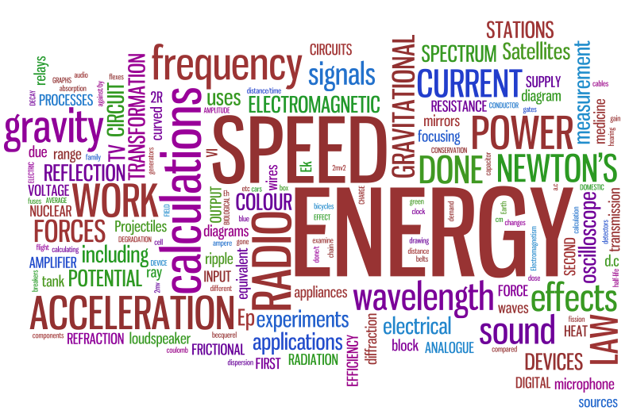
Da Vinci Design
Physics Syllabus 2015-2016

Instructor: Ms. Hannouche
Email: channouche@davincischools.org
Weebly: hannouchephysics.weebly.com
Physics Office Hours
Day Time
Tuesdays 4:00pm
Thursdays 8:00am
Course Description/Expectation:
Physics is the study of how the physical world works. Whether you want to be a scientist, poet, or professional soccer player, you will be able to see physics in your everyday life. You are expected to be present and to participate everyday in class. Physics requires a lot of attention, so it is expected that you spend time at home every day practicing physics.

Course Outline:

First Semester
Kinematics
Newton’s Laws
Momentum & Energy

Second Semester
Electricity & Magnetism
Thermodynamics
Waves

Required materials:

- Composition book
- Scientific Calculator
- Planner
- Ruler
- Glue OR Tape
- Pencil AND Eraser

Late Work/Makeup
Late assignments may be turned in up until the end of the unit. Accountability grade will go down by 1 point for each day that it is late.
Students are able to re-do assessments and projects once. Students have one week from the day the assessment or project has been returned to them to complete the makeup assessment or project (re-do assessments must be completed during office hours: not during class time). It is the students’ responsibility to schedule the make-up time with the teacher.

Absences
All work is included as part of your grade. If you are absent, it is your responsibility to get any work you missed while you were absent, including both classwork and homework assignments.
STUDENTS WITH MORE THAN 14 ABSENCES IN ANY SINGLE CLASS IN ONE SEMESTER MAY NOT RECEIVE CREDIT FOR THE CLASS, REGARDLESS OF GRADE.

Cell Phones
Cell phones will never be used in class. There is a zero tolerance policy on phones. If a phone is seen out for any reason it will be taken away

Grading
Da Vinci Design uses Mastery-Based Grading. Students’ grades will be based mainly upon their knowledge that correlates to the essential Physics skills (80%), as well as their usage of the Da Vinci Habits of Mind: Accountability, Collaboration, and Quality (20%).
Each student is responsible to meet all course requirements, including class participation, homework, quizzes, tests, teamwork, and projects. Several methods of assessment will be used during all semesters. Students’ projects will be graded on both an individual and group basis when applicable.

***Note: Any grade lower than a C- is considered not passing (incomplete) at Da Vinci. A student that receives a grade lower than a C- will be responsible for completing summer school, additional classes or special assignments and work to complete the class for credit.

Homework
Homework will be assigned daily, this is not for busy work, but because you must be practicing and thinking about physics while you are outside of class. Homework will be checked for completion at the beginning of every class and will be reviewed in class.

Class Expectations
- Be Respectful
I will respect myself, others and the classroom through my language and behavior
- Be Prepared
I will come to class with all my materials and with an attitude ready to learn and participate
- Follow Directions
Listen to all directions carefully and the first time they are given
- Try Your Best
Everyday is a different day, but you must bring your best effort and attitude every day

Cheating & Copying
Any student caught cheating, copying or plagiarizing will receive a Fail for the assignment. All participating students will receive that grade (I cannot tell who did the copying, so do not let anyone copy YOUR work). If a student is caught cheating more than once, they will be reported to the office and put on a cheating contract.

Office Hours
Students are expected to attend Office hours for any class at least once a week. Students must attended if they fail to complete homework assignments or is absent to class. Office hours can be used as a study hall, place to complete homework or to receive group/one-on-one tutoring.

Student Name: ___________________________________________________

Student Signature: ____________________________________________________

Parent/Guardian Name: ______________________________________________________

Parent/Guardian Signature: ___________________________________________________________

